IPL Analysis- RCB

NOTE: To improve query efficiency and maintain consistency, a consolidated view was created by joining ball-level data with match context.

CREATE OR REPLACE VIEW master_data AS
SELECT
b.Match_Id,
m.Season_Id,
b.Innings_No,
b.Over_Id,
b.Ball_Id,
b.Team_Batting,
b.Team_Bowling,
b.Striker,
b.Non_Striker,
b.Bowler,
b.Runs_Scored
FROM ball_by_ball b
JOIN matches m
ON b.Match_Id = m.Match_Id;

Objectives

1. List the different dtypes of columns in table “ball_by_ball” (using information schema)
A. The columns present in ball_by_ball table along with their datatypes are as follows:

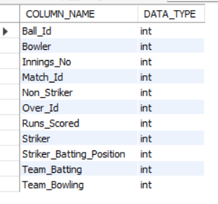
OUTPUT
SELECT
column_name,
data_type
FROM information_schema.columns
WHERE table_schema = DATABASE()
AND table_name = 'ball_by_ball';

2. What is the total number of runs scored in 1st season by RCB (bonus: also include the extra runs using the extra runs table)
A. The total number of runs scored by RCB in the 1st season is derived as follows:
- Joined ball-level master_data with extra runs to account for both runs scored off the bat and extra runs.
- Calculated total runs by summing runs scored and corresponding extras for each delivery.
- Filtered records to include only matches where RCB was the batting team.
- Identified the first available season in the dataset using the minimum Season_Id.
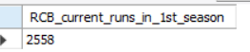
- Computed the total runs scored by RCB in the first season by aggregating all relevant deliveries. OUTPUT

SELECT
SUM(md.Runs_Scored + COALESCE(er.Extra_Runs, 0)) AS total_runs
FROM master_data md
LEFT JOIN extra_runs er
ON md.Match_Id = er.Match_Id
AND md.Innings_No = er.Innings_No
AND md.Over_Id = er.Over_Id
AND md.Ball_Id = er.Ball_Id
WHERE md.Team_Batting = 2
AND md.Season_Id = (
SELECT MIN(Season_Id)
FROM master_data
);
Hence, the total runs scored by team RCB in season 1 is 2558.
3. How many players were more than the age of 25 during season 2014?
A. To calculate the number of players having age>25 during season 2014, the following steps are taken:
- Joined player details with match participation to identify players who played matches.
- Linked matches to seasons to focus only on the 2014 season.
- Calculated each player’s age as of 31st December 2014 using date of birth.
- Filtered players whose age was greater than 25 during that season.
- Counted the distinct players satisfying the age condition to avoid duplicates.
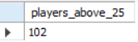
OUTPUT

SELECT
COUNT(DISTINCT p.Player_Id) AS players_above_25
FROM player p
JOIN player_match pm
ON p.Player_Id = pm.Player_Id
JOIN matches m
ON pm.Match_Id = m.Match_Id
JOIN season s
ON m.Season_Id = s.Season_Id
WHERE s.Season_Year = 2014
AND TIMESTAMPDIFF(YEAR, p.DOB, '2014-12-31') > 25;
So, the number of players who were above 25 years of age during season 2014 are 102.
4. How many matches did RCB win in 2013?
A. The count of wins by team RCB in 2013 is calculated by:
- Joined the matches table with the team table to identify the winning team for each match.
- Linked matches with the season table to filter matches played in the 2013 season.
- Filtered records to include only matches where Royal Challengers Bangalore was the winner.
- rcb_wins_2013
- 9
- Counted the total number of such matches to get RCB’s wins in 2013.
SELECT
COUNT(*) AS rcb_wins_2013
FROM matches m
JOIN team t
ON m.Match_Winner = t.Team_Id
JOIN season s
ON m.Season_Id = s.Season_Id
WHERE t.Team_Name = 'Royal Challengers Bangalore'
AND s.Season_Year = 2013;

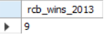
OUTPUT

The total number of matches won by RCB in 2013 are 9.

5. List the top 10 players according to their strike rate in the last 4 seasons.
A. Top 10 high strike-rate players:

- Selected ball-level batting data for each player using the striker information.
- Identified the last 4 available seasons dynamically from the dataset.
- Filtered records to include only deliveries from those last 4 seasons.
- 4. Calculated strike rate for each player as-
= (TotalRunsScored/TotalBallsFaced)×100.
- Applied a minimum ball faced threshold (≥ 100 balls) to remove unreliable short-sample performances.
- Ranked players by strike rate in descending order.
- Retrieved the top 10 players based on strike rate.
SELECT p.Player_Name,
ROUND((SUM(md.Runs_Scored) * 100.0 / COUNT(md.Ball_Id)), 2) AS strike_rate
FROM master_data md
JOIN player p ON md.Striker = p.Player_Id
JOIN ( SELECT Season_Id
FROM master_data
GROUP BY Season_Id
ORDER BY Season_Id DESC
LIMIT 4
) s
ON md.Season_Id = s.Season_Id
GROUP BY p.Player_Id, p.Player_Name
HAVING COUNT(md.Ball_Id) >= 100
ORDER BY strike_rate DESC
LIMIT 10;

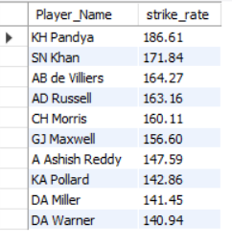
OUTPUT

The following column chart shows the top 10 batsmen with highest strike rates.

6. What are the average runs scored by each batsman considering all the seasons?
A. Average runs scored by each batsman:
- Selected ball-level batting records for each player using the striker identifier.
- Aggregated total runs scored by each player across all matches.
- Counted the distinct matches played by each player to avoid duplication.
- Calculated the average runs per match for each player by dividing total runs by matches played.
- Grouped results by player to compute individual statistics.
- Sorted players in descending order of average runs to highlight top performers.
SELECT
p.Player_Name,
SUM(md.Runs_Scored) AS total_runs,
COUNT(DISTINCT md.Match_Id) AS matches_played,
ROUND(SUM(md.Runs_Scored) / COUNT(DISTINCT md.Match_Id), 2) AS avg_runs
FROM master_data md
JOIN player p
ON md.Striker = p.Player_Id
GROUP BY p.Player_Id, p.Player_Name
ORDER BY avg_runs DESC;

ORDER BY avg_runs DESC;

OUTPUT
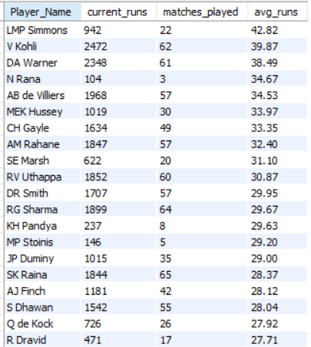

7. What are the average wickets taken by each bowler considering all the seasons?
A. Average wicket taken by each bowlers:
- Joined ball-level data with the wicket information to identify deliveries where wickets were taken.
- Linked each wicket to the corresponding bowler using the player table.
- Counted the total number of wickets taken by each bowler across all seasons.
- Counted the distinct matches in which each bowler bowled to avoid duplication.
- Calculated the average wickets per match for each bowler.
- Grouped results by bowler to compute individual bowling statistics.
- Sorted bowlers in descending order of average wickets to highlight the most effective performers.

SELECT
p.Player_Name,
COUNT(wt.Player_Out) AS total_wickets,
COUNT(DISTINCT md.Match_Id) AS matches_bowled,
ROUND(COUNT(wt.Player_Out) / COUNT(DISTINCT md.Match_Id), 2) AS avg_wickets
FROM master_data md
JOIN wicket_taken wt
ON md.Match_Id = wt.Match_Id
AND md.Innings_No = wt.Innings_No
AND md.Over_Id = wt.Over_Id
AND md.Ball_Id = wt.Ball_Id
JOIN player p
ON md.Bowler = p.Player_Id
GROUP BY p.Player_Id, p.Player_Name
ORDER BY avg_wickets DESC;

SELECT
p.Player_Name,
COUNT(wt.Player_Out) AS total_wickets,
COUNT(DISTINCT md.Match_Id) AS matches_bowled,
ROUND(COUNT(wt.Player_Out) / COUNT(DISTINCT md.Match_Id), 2) AS avg_wickets
FROM master_data md
JOIN wicket_taken wt
ON md.Match_Id = wt.Match_Id
AND md.Innings_No = wt.Innings_No
AND md.Over_Id = wt.Over_Id
AND md.Ball_Id = wt.Ball_Id
JOIN player p
ON md.Bowler = p.Player_Id
GROUP BY p.Player_Id, p.Player_Name
ORDER BY avg_wickets DESC;
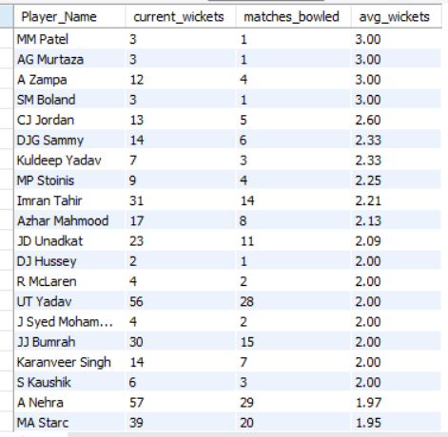
OUTPUT

8. List all the players who have average runs scored greater than the overall average and who have taken wickets greater than the overall average.
A. To solve this question following steps are performed:
- Calculated average runs per player as total runs scored divided by number of matches played.
- Calculated average wickets per player as total wickets taken divided by number of matches played.
- Computed overall batting average as the average of all players’ average runs.
- Computed overall bowling average as the average of all players’ average wickets.
- Identified players who have both average runs above the overall batting average and average wickets above the overall bowling average.
- Retrieved player names along with their individual averages and the corresponding overall averages for comparison.

OUTPUT
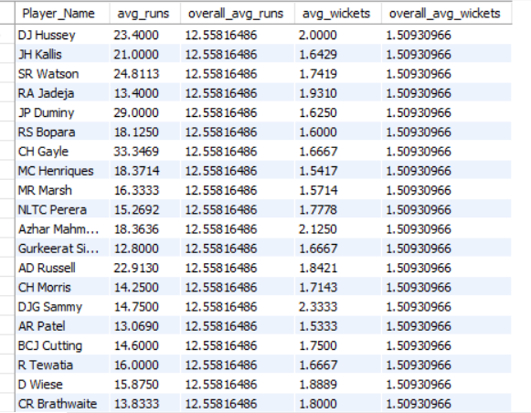

WITH batting_avg AS (
SELECT
md.Striker AS Player_Id,
SUM(md.Runs_Scored) / COUNT(DISTINCT md.Match_Id) AS avg_runs
FROM master_data md
GROUP BY md.Striker
),
bowling_avg AS (
SELECT
md.Bowler AS Player_Id,
COUNT(wt.Player_Out) / COUNT(DISTINCT md.Match_Id) AS avg_wickets
FROM master_data md
JOIN wicket_taken wt ON md.Match_Id = wt.Match_Id
AND md.Innings_No = wt.Innings_No
AND md.Over_Id = wt.Over_Id
AND md.Ball_Id = wt.Ball_Id
GROUP BY md.Bowler
),
overall_avg AS (
SELECT
(SELECT AVG(avg_runs) FROM batting_avg) AS overall_avg_runs,
(SELECT AVG(avg_wickets) FROM bowling_avg) AS overall_avg_wickets
)
SELECT
p.Player_Name,ba.avg_runs, oa.overall_avg_runs, bw.avg_wickets, oa.overall_avg_wickets
FROM batting_avg ba
JOIN bowling_avg bw ON ba.Player_Id = bw.Player_Id
JOIN overall_avg oa
JOIN player p ON p.Player_Id = ba.Player_Id
WHERE ba.avg_runs > oa.overall_avg_runs
AND bw.avg_wickets > oa.overall_avg_wickets;

WITH batting_avg AS (
SELECT
md.Striker AS Player_Id,
SUM(md.Runs_Scored) / COUNT(DISTINCT md.Match_Id) AS avg_runs
FROM master_data md
GROUP BY md.Striker
),
bowling_avg AS (
SELECT
md.Bowler AS Player_Id,
COUNT(wt.Player_Out) / COUNT(DISTINCT md.Match_Id) AS avg_wickets
FROM master_data md
JOIN wicket_taken wt ON md.Match_Id = wt.Match_Id
AND md.Innings_No = wt.Innings_No
AND md.Over_Id = wt.Over_Id
AND md.Ball_Id = wt.Ball_Id
GROUP BY md.Bowler
),
overall_avg AS (
SELECT
(SELECT AVG(avg_runs) FROM batting_avg) AS overall_avg_runs,
(SELECT AVG(avg_wickets) FROM bowling_avg) AS overall_avg_wickets
)
SELECT
p.Player_Name,ba.avg_runs, oa.overall_avg_runs, bw.avg_wickets, oa.overall_avg_wickets
FROM batting_avg ba
JOIN bowling_avg bw ON ba.Player_Id = bw.Player_Id
JOIN overall_avg oa
JOIN player p ON p.Player_Id = ba.Player_Id
WHERE ba.avg_runs > oa.overall_avg_runs
AND bw.avg_wickets > oa.overall_avg_wickets;

9. Create a table rcb_record table that shows the wins and losses of RCB in an individual venue.
A. rcb_record table showing RCB wins and losses:
Logical Steps-
- Dropped the rcb_record table if it already existed to avoid creation conflicts.
- Selected matches where Royal Challengers Bangalore (Team_Id = 2) participated.
- Joined match data with venue details to analyze performance venue-wise.
- Counted a win when RCB was the match winner.
- Counted a loss when RCB played the match but did not win (excluding no-result matches).
- Grouped the results by venue ID and venue name to get venue-specific records.
- Created the rcb_record table to store RCB’s wins and losses per venue.
- Retrieved all records from the rcb_record table for review.
DROP TABLE IF EXISTS rcb_record;
CREATE TABLE rcb_record AS
SELECT
v.Venue_Id,
v.Venue_Name,
SUM(CASE WHEN m.Match_Winner = 2 THEN 1 ELSE 0 END) AS wins,
SUM(CASE WHEN m.Match_Winner IS NOT NULL
AND m.Match_Winner <> 2 THEN 1 ELSE 0 END) AS losses
FROM matches m
JOIN venue v
ON m.Venue_Id = v.Venue_Id
WHERE 2 IN (m.Team_1, m.Team_2)
GROUP BY v.Venue_Id, v.Venue_Name;
select * from rcb_record;

DROP TABLE IF EXISTS rcb_record;
CREATE TABLE rcb_record AS
SELECT
v.Venue_Id,
v.Venue_Name,
SUM(CASE WHEN m.Match_Winner = 2 THEN 1 ELSE 0 END) AS wins,
SUM(CASE WHEN m.Match_Winner IS NOT NULL
AND m.Match_Winner <> 2 THEN 1 ELSE 0 END) AS losses
FROM matches m
JOIN venue v
ON m.Venue_Id = v.Venue_Id
WHERE 2 IN (m.Team_1, m.Team_2)
GROUP BY v.Venue_Id, v.Venue_Name;
select * from rcb_record;

OUTPUT
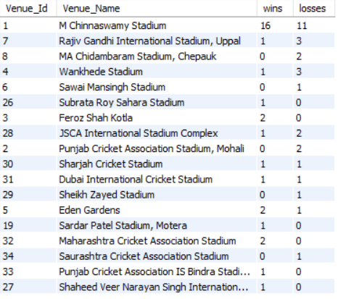
10. What is the impact of bowling style on wickets taken?
A. Impact of different bowling styles on wicket performances:
SELECT
bs.Bowling_skill,
COUNT(wt.Player_Out) AS total_wickets
FROM master_data md
JOIN wicket_taken wt
ON md.Match_Id = wt.Match_Id
AND md.Innings_No = wt.Innings_No
AND md.Over_Id = wt.Over_Id
AND md.Ball_Id = wt.Ball_Id
JOIN player p
ON md.Bowler = p.Player_Id
JOIN bowling_style bs
ON p.Bowling_skill = bs.Bowling_Id
GROUP BY bs.Bowling_skill
ORDER BY total_wickets DESC;

SELECT
bs.Bowling_skill,
COUNT(wt.Player_Out) AS total_wickets
FROM master_data md
JOIN wicket_taken wt
ON md.Match_Id = wt.Match_Id
AND md.Innings_No = wt.Innings_No
AND md.Over_Id = wt.Over_Id
AND md.Ball_Id = wt.Ball_Id
JOIN player p
ON md.Bowler = p.Player_Id
JOIN bowling_style bs
ON p.Bowling_skill = bs.Bowling_Id
GROUP BY bs.Bowling_skill
ORDER BY total_wickets DESC;

Logical Steps-
- Joined ball-level data with wicket information to identify deliveries where wickets were taken.
- Mapped each wicket to the corresponding bowler using the player table.
- Linked bowlers to their bowling styles using the bowling_style table.
- Counted the total number of wickets taken for each bowling style.
- Grouped results by bowling style to aggregate wickets style-wise.
- Sorted bowling styles in descending order of total wickets to assess their impact.
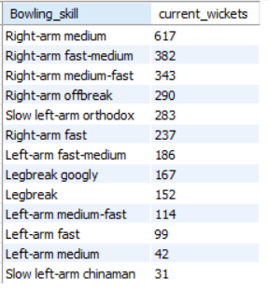
OUTPUT

11. Write the SQL query to provide a status of whether the performance of the team is better than the previous year's performance on the basis of the number of runs scored by the team in the season and the number of wickets taken.
A. RCB’s season-wise performance was evaluated by comparing total runs scored and total wickets taken in each season against the immediately previous season. Based on the year-over-year comparison, each season was classified as Better, Worse, or Mixed to highlight performance trends over time.
Performance Status logic:
Rules used:
- Better
  - Runs increased AND
  - Wickets increased
- Worse
  - Runs decreased AND
  - Wickets decreased
- Mixed
  - One increased, one decreased (or unchanged)

OUTPUT
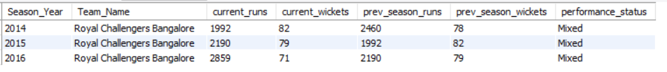

WITH season_perf AS (
SELECT s.Season_Year, t.Team_Name,
SUM(md.Runs_Scored) AS current_runs,
COUNT(wt.Player_Out) AS current_wickets
FROM master_data md
JOIN matches m ON md.Match_Id = m.Match_Id
JOIN season s ON m.Season_Id = s.Season_Id
JOIN team t ON md.Team_Batting = t.Team_Id
LEFT JOIN wicket_taken wt ON md.Match_Id = wt.Match_Id
AND md.Innings_No = wt.Innings_No
AND md.Over_Id = wt.Over_Id
AND md.Ball_Id = wt.Ball_Id
WHERE t.Team_Name = 'Royal Challengers Bangalore'
GROUP BY s.Season_Year, t.Team_Name
),
season_compare AS (
SELECT Season_Year, Team_Name, current_runs, current_wickets,
LAG(current_runs) OVER (ORDER BY Season_Year) AS prev_season_runs,
LAG(current_wickets) OVER (ORDER BY Season_Year) AS prev_season_wickets
FROM season_perf
)
SELECT Season_Year, Team_Name, current_runs, current_wickets, prev_season_runs,
prev_season_wickets,
CASE
WHEN current_runs > prev_season_runs
AND current_wickets > prev_season_wickets THEN 'Better'
WHEN current_runs < prev_season_runs
AND current_wickets < prev_season_wickets THEN 'Worse'
ELSE 'Mixed'
END AS performance_status
FROM season_compare
WHERE prev_season_runs IS NOT NULL;

year | current runs | prv runs
2014 | 1992 | 2460
2015 | 2190 | 1992
2016 | 2859 | 2190
- Total Runs Comparison & Visualization:

OUTPUT

year | current wickets | pvs wickets
2014 | 82 | 78
2015 | 79 | 82
2016 | 71 | 79
- Total Wickets Comparison & Visualization:
OUTPUT

12.Can you derive more KPIs for the team strategy?
A. I’ve analyzed player and team performances over the last 4 seasons to derive strategy-focused KPIs that help in player selection, match planning, and risk management, rather than repeating common powerplay/death-over analyses.

1. Boundary Dependency KPI (Role of Boundaries): This KPI highlights batsmen who perform well during high-impact phases of the game—Powerplay for fast starts and Death Overs for finishing—making them valuable under pressure situations.
- Selected batting records for each player based on the striker information.
- Filtered the data to include only the last 4 seasons of available matches.
- Calculated the total runs scored by each batsman across those seasons.
- Segmented runs scored into Powerplay overs (1–6) and Death overs (16–20) to assess phase-wise performance.
- Counted the distinct matches played by each batsman to provide context to their run contributions.
- Grouped results by player to compute individual batting metrics.
- Ranked players by total runs scored and selected the top 20 performers for analysis.

OUTPUT
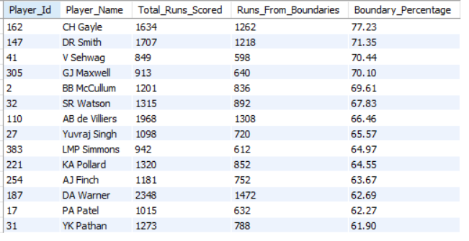
SELECT
md.Striker AS Player_Id,
p.Player_Name,
SUM(md.Runs_Scored) AS Total_Runs_Scored,
SUM(CASE
WHEN md.Runs_Scored IN (4, 6) THEN md.Runs_Scored
ELSE 0
END) AS Runs_From_Boundaries,
ROUND(
(SUM(CASE WHEN md.Runs_Scored IN (4, 6) THEN md.Runs_Scored ELSE 0 END)
/ SUM(md.Runs_Scored)) * 100, 2
) AS Boundary_Percentage
FROM master_data md
JOIN player p
ON md.Striker = p.Player_Id
JOIN (
SELECT Season_Id
FROM master_data
GROUP BY Season_Id
ORDER BY Season_Id DESC
LIMIT 4
) s
ON md.Season_Id = s.Season_Id
GROUP BY md.Striker, p.Player_Name
HAVING Total_Runs_Scored > 800
AND Boundary_Percentage > 60
ORDER BY Boundary_Percentage DESC;

SELECT
md.Striker AS Player_Id,
p.Player_Name,
SUM(md.Runs_Scored) AS Total_Runs_Scored,
SUM(CASE
WHEN md.Runs_Scored IN (4, 6) THEN md.Runs_Scored
ELSE 0
END) AS Runs_From_Boundaries,
ROUND(
(SUM(CASE WHEN md.Runs_Scored IN (4, 6) THEN md.Runs_Scored ELSE 0 END)
/ SUM(md.Runs_Scored)) * 100, 2
) AS Boundary_Percentage
FROM master_data md
JOIN player p
ON md.Striker = p.Player_Id
JOIN (
SELECT Season_Id
FROM master_data
GROUP BY Season_Id
ORDER BY Season_Id DESC
LIMIT 4
) s
ON md.Season_Id = s.Season_Id
GROUP BY md.Striker, p.Player_Name
HAVING Total_Runs_Scored > 800
AND Boundary_Percentage > 60
ORDER BY Boundary_Percentage DESC;

2. Player Dependency KPI (Team Reliance on Individual Players): This KPI highlights over-dependence on specific players. High dependency increases risk during injuries, poor form, or opposition targeting.
WITH last_4_seasons AS (
SELECT Season_Id
FROM master_data
GROUP BY Season_Id
ORDER BY Season_Id DESC
LIMIT 4
),
team_total_runs AS (
SELECT md.Team_Batting AS Team_Id, SUM(md.Runs_Scored) AS team_runs
FROM master_data md
JOIN last_4_seasons l4 ON md.Season_Id = l4.Season_Id
GROUP BY md.Team_Batting
),
player_team_runs AS (
SELECT md.Team_Batting AS Team_Id, t.Team_Name, md.Striker AS Player_Id
p.Player_Name,
SUM(md.Runs_Scored) AS player_runs
FROM master_data md
JOIN last_4_seasons l4 ON md.Season_Id = l4.Season_Id
JOIN team t ON md.Team_Batting = t.Team_Id
JOIN player p ON md.Striker = p.Player_Id
GROUP BY md.Team_Batting, t.Team_Name, md.Striker, p.Player_Name
),
dependency_rank AS (
SELECT ptr.Team_Id, ptr.Team_Name, ptr.Player_Name,
ROUND((ptr.player_runs * 100.0) / ttr.team_runs, 2) AS dependency_percentage,
ROW_NUMBER() OVER (
PARTITION BY ptr.Team_Id
ORDER BY (ptr.player_runs * 1.0 / ttr.team_runs) DESC
) AS rn
FROM player_team_runs ptr
JOIN team_total_runs ttr ON ptr.Team_Id = ttr.Team_Id
)
SELECT Team_Name, Player_Name, dependency_percentage
FROM dependency_rank
WHERE rn = 1
ORDER BY dependency_percentage DESC;

WITH last_4_seasons AS (
SELECT Season_Id
FROM master_data
GROUP BY Season_Id
ORDER BY Season_Id DESC
LIMIT 4
),
team_total_runs AS (
SELECT md.Team_Batting AS Team_Id, SUM(md.Runs_Scored) AS team_runs
FROM master_data md
JOIN last_4_seasons l4 ON md.Season_Id = l4.Season_Id
GROUP BY md.Team_Batting
),
player_team_runs AS (
SELECT md.Team_Batting AS Team_Id, t.Team_Name, md.Striker AS Player_Id
p.Player_Name,
SUM(md.Runs_Scored) AS player_runs
FROM master_data md
JOIN last_4_seasons l4 ON md.Season_Id = l4.Season_Id
JOIN team t ON md.Team_Batting = t.Team_Id
JOIN player p ON md.Striker = p.Player_Id
GROUP BY md.Team_Batting, t.Team_Name, md.Striker, p.Player_Name
),
dependency_rank AS (
SELECT ptr.Team_Id, ptr.Team_Name, ptr.Player_Name,
ROUND((ptr.player_runs * 100.0) / ttr.team_runs, 2) AS dependency_percentage,
ROW_NUMBER() OVER (
PARTITION BY ptr.Team_Id
ORDER BY (ptr.player_runs * 1.0 / ttr.team_runs) DESC
) AS rn
FROM player_team_runs ptr
JOIN team_total_runs ttr ON ptr.Team_Id = ttr.Team_Id
)
SELECT Team_Name, Player_Name, dependency_percentage
FROM dependency_rank
WHERE rn = 1
ORDER BY dependency_percentage DESC;

Logical Steps-
- Identified the last 4 seasons dynamically from the dataset to ensure recent performance analysis.
- Calculated the total runs scored by each team across those last 4 seasons.
- Calculated the total runs scored by each player for their respective teams during the same period.
- Computed each player’s dependency percentage as the proportion of team runs contributed by that player.
- Ranked players within each team based on their dependency percentage using a window function.
- Selected the top-ranked (most depended-on) player for each team.
g. Sorted teams in descending order of dependency percentage to identify teams with the highest individual player reliance.
OUTPUT
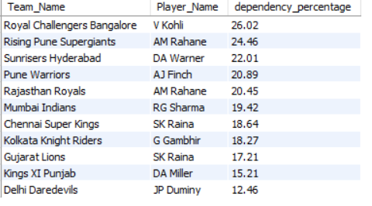

3. Star-Players KPI (Awardees from each Team): This KPI identifies star players who have consistently delivered match-winning performances across multiple seasons, as reflected by major individual awards. Such players are high-reliability assets and can be considered strong candidates for future team building and auction strategies.
- Identified the last 4 seasons dynamically from the dataset to ensure recent performance analysis.
- Calculated the total runs scored by each team across those last 4 seasons.
- Calculated the total runs scored by each player for their respective teams during the same period.
- Computed each player’s dependency percentage as the proportion of team runs contributed by that player.
- Ranked players within each team based on their dependency percentage using a window function.
- Selected the top-ranked (most depended-on) player for each team.
- Sorted teams in descending order of dependency percentage to identify teams with the highest individual player reliance.
SELECT
p.Player_Id,
p.Player_Name,
SUM(CASE WHEN s.Man_of_the_Series = p.Player_Id THEN 1 ELSE 0 END) AS Man_of_Series_Count,
SUM(CASE WHEN s.Orange_Cap = p.Player_Id THEN 1 ELSE 0 END) AS Orange_Cap_Count,
SUM(CASE WHEN s.Purple_Cap = p.Player_Id THEN 1 ELSE 0 END) AS Purple_Cap_Count,
(
SUM(CASE WHEN s.Man_of_the_Series = p.Player_Id THEN 1 ELSE 0 END) * 3 +
SUM(CASE WHEN s.Orange_Cap = p.Player_Id THEN 1 ELSE 0 END) * 2 +
SUM(CASE WHEN s.Purple_Cap = p.Player_Id THEN 1 ELSE 0 END) * 2
) AS Star_Player_Weightage
FROM season s
JOIN player p
ON p.Player_Id IN (s.Man_of_the_Series, s.Orange_Cap, s.Purple_Cap)
GROUP BY p.Player_Id, p.Player_Name
HAVING Star_Player_Weightage > 0
ORDER BY Star_Player_Weightage DESC;

SELECT
p.Player_Id,
p.Player_Name,
SUM(CASE WHEN s.Man_of_the_Series = p.Player_Id THEN 1 ELSE 0 END) AS Man_of_Series_Count,
SUM(CASE WHEN s.Orange_Cap = p.Player_Id THEN 1 ELSE 0 END) AS Orange_Cap_Count,
SUM(CASE WHEN s.Purple_Cap = p.Player_Id THEN 1 ELSE 0 END) AS Purple_Cap_Count,
(
SUM(CASE WHEN s.Man_of_the_Series = p.Player_Id THEN 1 ELSE 0 END) * 3 +
SUM(CASE WHEN s.Orange_Cap = p.Player_Id THEN 1 ELSE 0 END) * 2 +
SUM(CASE WHEN s.Purple_Cap = p.Player_Id THEN 1 ELSE 0 END) * 2
) AS Star_Player_Weightage
FROM season s
JOIN player p
ON p.Player_Id IN (s.Man_of_the_Series, s.Orange_Cap, s.Purple_Cap)
GROUP BY p.Player_Id, p.Player_Name
HAVING Star_Player_Weightage > 0
ORDER BY Star_Player_Weightage DESC;

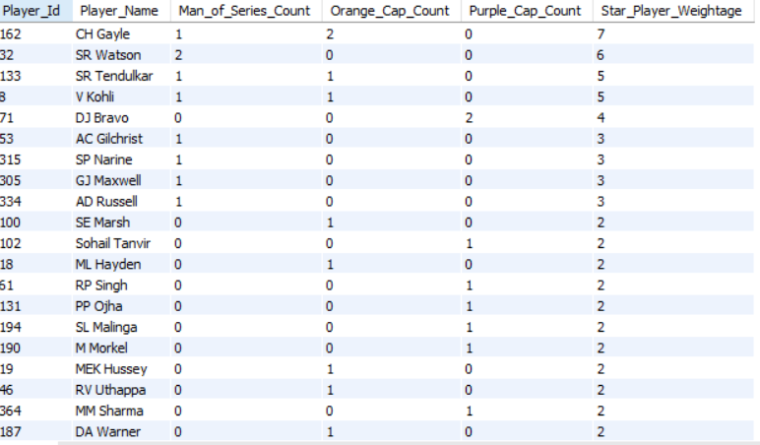
OUTPUT

4. All-Round Impact KPI (Balanced Contributors): This KPI highlights true all-rounders who consistently contribute with both bat and ball, making them valuable for team balance and strategic flexibility in future matches and auctions.
SELECT
p.Player_Name,
SUM(md.Runs_Scored) AS Total_Runs,
COUNT(wt.Player_Out) AS Total_Wickets
FROM master_data md
LEFT JOIN wicket_taken wt
ON md.Match_Id = wt.Match_Id
AND md.Innings_No = wt.Innings_No
AND md.Over_Id = wt.Over_Id
AND md.Ball_Id = wt.Ball_Id
JOIN player p
ON p.Player_Id IN (md.Striker, md.Bowler)
JOIN (
SELECT Season_Id
FROM master_data
GROUP BY Season_Id
ORDER BY Season_Id DESC
LIMIT 4
) s
ON md.Season_Id = s.Season_Id
GROUP BY p.Player_Id, p.Player_Name
HAVING Total_Runs > 500 AND Total_Wickets > 20
ORDER BY Total_Runs desc, Total_Wickets desc;

SELECT
p.Player_Name,
SUM(md.Runs_Scored) AS Total_Runs,
COUNT(wt.Player_Out) AS Total_Wickets
FROM master_data md
LEFT JOIN wicket_taken wt
ON md.Match_Id = wt.Match_Id
AND md.Innings_No = wt.Innings_No
AND md.Over_Id = wt.Over_Id
AND md.Ball_Id = wt.Ball_Id
JOIN player p
ON p.Player_Id IN (md.Striker, md.Bowler)
JOIN (
SELECT Season_Id
FROM master_data
GROUP BY Season_Id
ORDER BY Season_Id DESC
LIMIT 4
) s
ON md.Season_Id = s.Season_Id
GROUP BY p.Player_Id, p.Player_Name
HAVING Total_Runs > 500 AND Total_Wickets > 20
ORDER BY Total_Runs desc, Total_Wickets desc;

OUTPUT
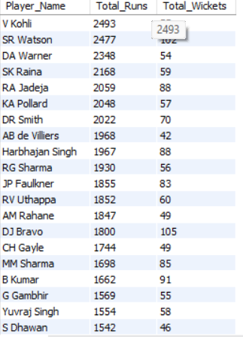

Logical Steps-
- Selected player-level data from the master_data view to capture both batting and bowling contributions.
- Joined wicket information to identify deliveries where wickets were taken.
- Filtered the dataset to include only the last 4 seasons for recent performance relevance.
- Aggregated total runs scored by each player across those seasons.
- Aggregated total wickets taken by each player across the same period.
- Grouped results at the player level to combine batting and bowling performance.
- Filtered players who crossed minimum thresholds of 500 runs and 20 wickets to identify meaningful all-round contributions.
- Ordered players by runs and wickets to highlight top all-round performers.

13. Using SQL, write a query to find out the average wickets taken by each bowler in each venue. Also, rank the bowlers according to the average value.
A. The query show that bowlers’ effectiveness varies across venues, indicating that certain bowlers perform consistently better at specific grounds due to pitch conditions and ground characteristics.
WITH bowler_venue_stats AS (
SELECT v.Venue_Id, v.Venue_Name, p.Player_Name,
COUNT(wt.Player_Out) AS Total_Wickets_Taken,
COUNT(DISTINCT m.Match_Id) AS Total_Matches_Played,
ROUND(
COUNT(wt.Player_Out) / COUNT(DISTINCT m.Match_Id),2) AS Avg_Wickets
FROM wicket_taken wt
JOIN ball_by_ball bb ON wt.Match_Id = bb.Match_Id
AND wt.Innings_No = bb.Innings_No
AND wt.Over_Id = bb.Over_Id
AND wt.Ball_Id = bb.Ball_Id
JOIN matches m ON wt.Match_Id = m.Match_Id
JOIN venue v ON m.Venue_Id = v.Venue_Id
JOIN player p ON bb.Bowler = p.Player_Id
GROUP BY v.Venue_Id, v.Venue_Name, p.Player_Name
HAVING COUNT(DISTINCT m.Match_Id) > 10
)
SELECT
Venue_Name, Player_Name, Total_Matches_Played, Total_Wickets_Taken,
Avg_Wickets,
DENSE_RANK() OVER (ORDER BY Avg_Wickets DESC) AS Venue_Rank
FROM bowler_venue_stats
ORDER BY Venue_Rank;

WITH bowler_venue_stats AS (
SELECT v.Venue_Id, v.Venue_Name, p.Player_Name,
COUNT(wt.Player_Out) AS Total_Wickets_Taken,
COUNT(DISTINCT m.Match_Id) AS Total_Matches_Played,
ROUND(
COUNT(wt.Player_Out) / COUNT(DISTINCT m.Match_Id),2) AS Avg_Wickets
FROM wicket_taken wt
JOIN ball_by_ball bb ON wt.Match_Id = bb.Match_Id
AND wt.Innings_No = bb.Innings_No
AND wt.Over_Id = bb.Over_Id
AND wt.Ball_Id = bb.Ball_Id
JOIN matches m ON wt.Match_Id = m.Match_Id
JOIN venue v ON m.Venue_Id = v.Venue_Id
JOIN player p ON bb.Bowler = p.Player_Id
GROUP BY v.Venue_Id, v.Venue_Name, p.Player_Name
HAVING COUNT(DISTINCT m.Match_Id) > 10
)
SELECT
Venue_Name, Player_Name, Total_Matches_Played, Total_Wickets_Taken,
Avg_Wickets,
DENSE_RANK() OVER (ORDER BY Avg_Wickets DESC) AS Venue_Rank
FROM bowler_venue_stats
ORDER BY Venue_Rank;

OUTPUT
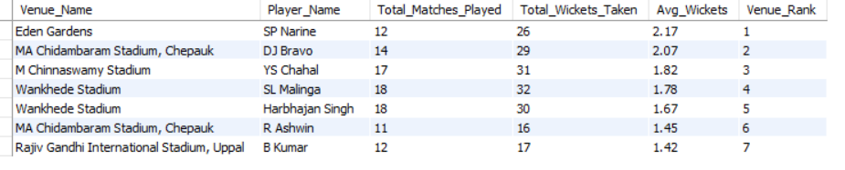

- Started from the wicket_taken table since the analysis is wicket-focused, ensuring each record represents a valid wicket event.
- Joined ball-level data to identify the bowler responsible for each wicket.
- Linked match and venue information to associate each wicket with its venue.
- Aggregated the total number of wickets taken by each bowler at each venue.
- Calculated the total number of matches played by each bowler at each venue.
- Derived the average wickets per match by dividing total wickets by total matches played.
- Filtered bowlers who have played more than 10 matches at a venue to ensure reliable averages.
- Ranked bowlers using DENSE_RANK() based on average wickets so that no ranks are skipped.
- Displayed venue-wise bowler performance along with matches played, wickets taken, average wickets, and rank.

14. Which of the given players have consistently performed well in past seasons? (will you use any visualization to solve the problem).
A. To find the consistent performance of players, the solution is divided into to parts:
- Batting Consistency: Batsmen with lower runs variation demonstrate stable performance across seasons, indicating reliability and consistency, while higher variation reflects fluctuating performance despite similar average outputs.
[NOTE: Runs variation represents the season-to-season fluctuation in a player’s run-scoring performance, where lower variation indicates higher consistency.
STDDEV(Season_Runs)-
- It is a statistical measure of dispersion
- Commonly used in performance stability analysis
- Captures volatility, not just volume
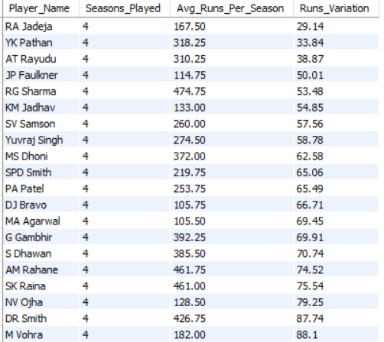
OUTPUT

WITH batting_season_perf AS (
SELECT md.Striker AS Player_Id, p.Player_Name, md.Season_Id,
SUM(md.Runs_Scored) AS Season_Runs,
COUNT(md.Ball_Id) AS Balls_Faced
FROM master_data md
JOIN player p ON md.Striker = p.Player_Id
GROUP BY md.Striker, p.Player_Name, md.Season_Id
),
batting_consistency AS (
SELECT Player_Id, Player_Name,
COUNT(Season_Id) AS Seasons_Played,
SUM(Season_Runs) AS Total_Runs,
SUM(Balls_Faced) AS Total_Balls,
ROUND(AVG(Season_Runs), 2) AS Avg_Runs_Per_Season,
ROUND(STDDEV(Season_Runs), 2) AS Runs_Variation
FROM batting_season_perf
GROUP BY Player_Id, Player_Name
)
SELECT Player_Name, Seasons_Played, Avg_Runs_Per_Season, Runs_Variation
FROM batting_consistency
WHERE Seasons_Played > 3
AND Total_Balls >= 300
ORDER BY Runs_Variation ASC, Avg_Runs_Per_Season DESC;

WITH batting_season_perf AS (
SELECT md.Striker AS Player_Id, p.Player_Name, md.Season_Id,
SUM(md.Runs_Scored) AS Season_Runs,
COUNT(md.Ball_Id) AS Balls_Faced
FROM master_data md
JOIN player p ON md.Striker = p.Player_Id
GROUP BY md.Striker, p.Player_Name, md.Season_Id
),
batting_consistency AS (
SELECT Player_Id, Player_Name,
COUNT(Season_Id) AS Seasons_Played,
SUM(Season_Runs) AS Total_Runs,
SUM(Balls_Faced) AS Total_Balls,
ROUND(AVG(Season_Runs), 2) AS Avg_Runs_Per_Season,
ROUND(STDDEV(Season_Runs), 2) AS Runs_Variation
FROM batting_season_perf
GROUP BY Player_Id, Player_Name
)
SELECT Player_Name, Seasons_Played, Avg_Runs_Per_Season, Runs_Variation
FROM batting_consistency
WHERE Seasons_Played > 3
AND Total_Balls >= 300
ORDER BY Runs_Variation ASC, Avg_Runs_Per_Season DESC;

- Bowling Consistency: Bowlers with lower wickets variation demonstrate stable wicket-taking performance across seasons, indicating consistency and reliability, while higher variation reflects fluctuating effectiveness despite occasional high-performing seasons.
WITH bowling_season_perf AS (
SELECT
md.Bowler AS Player_Id,
p.Player_Name,
md.Season_Id,
COUNT(wt.Player_Out) AS Season_Wickets
FROM master_data md
JOIN wicket_taken wt
ON md.Match_Id = wt.Match_Id
AND md.Innings_No = wt.Innings_No
AND md.Over_Id = wt.Over_Id
AND md.Ball_Id = wt.Ball_Id
JOIN player p
ON md.Bowler = p.Player_Id
GROUP BY md.Bowler, p.Player_Name, md.Season_Id
),
bowling_consistency AS (
SELECT
Player_Id,
Player_Name,
COUNT(Season_Id) AS Seasons_Played,
SUM(Season_Wickets) AS Total_Wickets,
ROUND(AVG(Season_Wickets), 2) AS Avg_Wickets_Per_Season,
ROUND(STDDEV(Season_Wickets), 2) AS Wickets_Variation
FROM bowling_season_perf
GROUP BY Player_Id, Player_Name
)
SELECT
Player_Name,
Seasons_Played,
Avg_Wickets_Per_Season,
Wickets_Variation
FROM bowling_consistency
WHERE Seasons_Played > 3
AND Total_Wickets >= 30
ORDER BY Wickets_Variation ASC, Avg_Wickets_Per_Season DESC;

WITH bowling_season_perf AS (
SELECT
md.Bowler AS Player_Id,
p.Player_Name,
md.Season_Id,
COUNT(wt.Player_Out) AS Season_Wickets
FROM master_data md
JOIN wicket_taken wt
ON md.Match_Id = wt.Match_Id
AND md.Innings_No = wt.Innings_No
AND md.Over_Id = wt.Over_Id
AND md.Ball_Id = wt.Ball_Id
JOIN player p
ON md.Bowler = p.Player_Id
GROUP BY md.Bowler, p.Player_Name, md.Season_Id
),
bowling_consistency AS (
SELECT
Player_Id,
Player_Name,
COUNT(Season_Id) AS Seasons_Played,
SUM(Season_Wickets) AS Total_Wickets,
ROUND(AVG(Season_Wickets), 2) AS Avg_Wickets_Per_Season,
ROUND(STDDEV(Season_Wickets), 2) AS Wickets_Variation
FROM bowling_season_perf
GROUP BY Player_Id, Player_Name
)
SELECT
Player_Name,
Seasons_Played,
Avg_Wickets_Per_Season,
Wickets_Variation
FROM bowling_consistency
WHERE Seasons_Played > 3
AND Total_Wickets >= 30
ORDER BY Wickets_Variation ASC, Avg_Wickets_Per_Season DESC;

OUTPUT
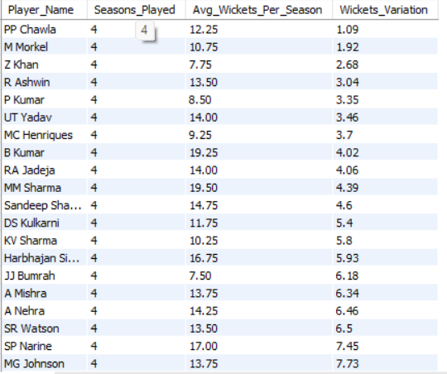

Conclusion:

By analyzing both batting consistency and bowling consistency graphs, players who combine strong average performance with low season-to-season variation emerge as the most consistent performers in past seasons. These players deliver steady contributions year after year, unlike players who show high averages but large fluctuations driven by a few peak seasons. Overall, the combined visual analysis confirms that consistency is best identified through stable trends rather than isolated high performances, making such players more reliable choices for long-term team planning.

15. Are there players whose performance is more suited to specific venues or conditions? (how would you present this using charts?).
A. 1. Batting: Venue-wise Player Performance: The results indicate that certain batsmen consistently perform better at specific venues, suggesting that venue conditions and familiarity play a significant role in batting performance. This analysis helps identify venue-specific batting strengths, which can support informed team selection and match strategy decisions.
- Joined ball-level data with match and venue information to associate each batting record with its corresponding venue.
- Grouped data by player and venue to evaluate venue-specific batting performance.
- Calculated the total runs scored by each player at each venue.
- Counted the total matches played by each player at each venue using distinct match counts.
- Derived the average runs per match by dividing total runs by matches played.
- Applied a minimum threshold of at least 5 matches played at a venue to ensure reliability.
- Applied a minimum threshold of more than 100 balls faced to include only players with significant batting involvement.
- Ranked players based on total runs scored to identify top venue-specific batting performances.
- Selected the top 20 player–venue combinations for analysis.
SELECT
v.Venue_Name,
p.Player_Name,
COUNT(DISTINCT md.Match_Id) AS Matches_Played,
SUM(md.Runs_Scored) AS Total_Runs,
ROUND(SUM(md.Runs_Scored) / COUNT(DISTINCT md.Match_Id), 2) AS Avg_Runs_Per_Match
FROM master_data md
JOIN matches m
ON md.Match_Id = m.Match_Id
JOIN venue v
ON m.Venue_Id = v.Venue_Id
JOIN player p
ON md.Striker = p.Player_Id
GROUP BY md.Striker, p.Player_Name, v.Venue_Name
HAVING COUNT(DISTINCT md.Match_Id) >= 5
and count(md.Ball_Id)>100
ORDER BY Total_Runs DESC
limit 20;

SELECT
v.Venue_Name,
p.Player_Name,
COUNT(DISTINCT md.Match_Id) AS Matches_Played,
SUM(md.Runs_Scored) AS Total_Runs,
ROUND(SUM(md.Runs_Scored) / COUNT(DISTINCT md.Match_Id), 2) AS Avg_Runs_Per_Match
FROM master_data md
JOIN matches m
ON md.Match_Id = m.Match_Id
JOIN venue v
ON m.Venue_Id = v.Venue_Id
JOIN player p
ON md.Striker = p.Player_Id
GROUP BY md.Striker, p.Player_Name, v.Venue_Name
HAVING COUNT(DISTINCT md.Match_Id) >= 5
and count(md.Ball_Id)>100
ORDER BY Total_Runs DESC
limit 20;

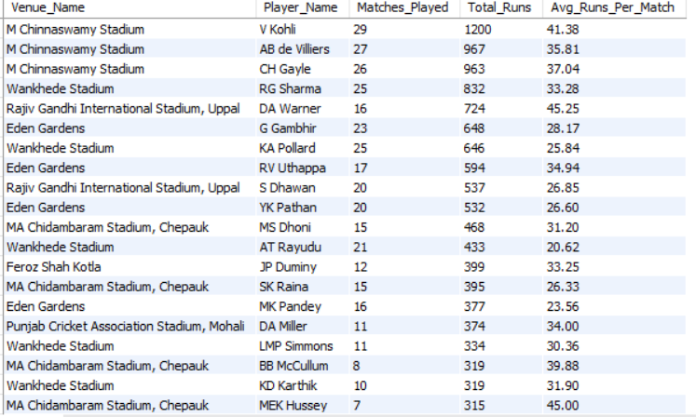
OUTPUT

Conclusion:
The below visualization clearly shows that batting performance varies significantly across venues, with certain players consistently scoring higher average runs at specific grounds. Venues like M. Chinnaswamy Stadium and MA Chidambaram Stadium (Chepauk) highlight strong venue–player combinations, indicating that ground conditions and familiarity play an important role in batting success. Overall, the chart confirms that player effectiveness is venue-dependent, and such insights can be used to make better-informed decisions on player selection and batting order based on match location.

2. Bowling: Venue-wise Player Performance: The analysis reveals that bowlers tend to be more effective at certain venues, with higher wicket-taking rates at specific grounds. This indicates that pitch conditions and venue characteristics significantly influence bowling performance, making venue-specific bowler selection an important factor in match strategy.
- Joined ball-level data to correctly associate each wicket with the bowler.
- Linked match and venue information to map each wicket to its venue.
- Grouped data by bowler and venue to analyze venue-specific bowling performance.
- Calculated the total wickets taken by each bowler at each venue.
- Counted the number of matches played by each bowler at each venue using distinct match counts.
- Derived the average wickets per match by dividing total wickets by matches played.
- Applied a minimum threshold of at least 5 matches at a venue to ensure reliable statistics.
- Ranked the results by total wickets taken to highlight the most effective bowlers at specific venues.
- Selected the top 20 bowler–venue combinations for focused analysis.
SELECT
v.Venue_Name,
p.Player_Name,
COUNT(DISTINCT m.Match_Id) AS Matches_Played,
COUNT(wt.Player_Out) AS Total_Wickets,
ROUND(COUNT(wt.Player_Out) / COUNT(DISTINCT m.Match_Id),2) AS Avg_Wickets_Per_Match
FROM wicket_taken wt
JOIN ball_by_ball bb
ON wt.Match_Id = bb.Match_Id
AND wt.Innings_No = bb.Innings_No
AND wt.Over_Id = bb.Over_Id
AND wt.Ball_Id = bb.Ball_Id
JOIN matches m
ON wt.Match_Id = m.Match_Id
JOIN venue v
ON m.Venue_Id = v.Venue_Id
JOIN player p
ON bb.Bowler = p.Player_Id
GROUP BY bb.Bowler,p.Player_Name, v.Venue_Name
HAVING COUNT(DISTINCT m.Match_Id) >= 5
ORDER BY Total_Wickets DESC
limit 20;

SELECT
v.Venue_Name,
p.Player_Name,
COUNT(DISTINCT m.Match_Id) AS Matches_Played,
COUNT(wt.Player_Out) AS Total_Wickets,
ROUND(COUNT(wt.Player_Out) / COUNT(DISTINCT m.Match_Id),2) AS Avg_Wickets_Per_Match
FROM wicket_taken wt
JOIN ball_by_ball bb
ON wt.Match_Id = bb.Match_Id
AND wt.Innings_No = bb.Innings_No
AND wt.Over_Id = bb.Over_Id
AND wt.Ball_Id = bb.Ball_Id
JOIN matches m
ON wt.Match_Id = m.Match_Id
JOIN venue v
ON m.Venue_Id = v.Venue_Id
JOIN player p
ON bb.Bowler = p.Player_Id
GROUP BY bb.Bowler,p.Player_Name, v.Venue_Name
HAVING COUNT(DISTINCT m.Match_Id) >= 5
ORDER BY Total_Wickets DESC
limit 20;

OUTPUT
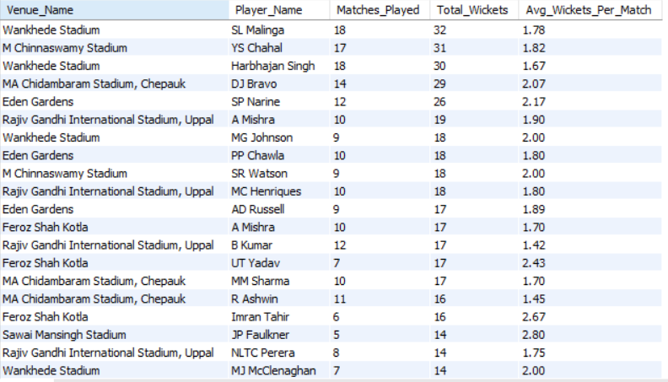

Conclusion:

The below visualization shows that bowling performance is highly venue-dependent, with certain bowlers consistently taking more wickets per match at specific grounds. Venues like Eden Gardens, Feroz Shah Kotla, and MA Chidambaram Stadium (Chepauk) highlight strong bowler–venue combinations, reflecting the influence of pitch conditions such as spin assistance, bounce, and ground dimensions. Overall, the chart confirms that bowler effectiveness varies by venue, and selecting bowlers based on venue-specific historical performance can significantly improve match outcomes.

Subjectives
1. How does the toss decision affect the result of the match? (which visualizations could be used to present your answer better) And is the impact limited to only specific venues?
A. This analysis aims to evaluate whether winning the toss provides a measurable advantage in determining match outcomes and to examine whether this impact varies across different venues.

I. Correlation of Tossing on Match Performance: The toss is often believed to provide a strategic advantage in cricket, as it allows a team to decide whether to bat or field based on pitch and match conditions. However, such beliefs need data validation.
Therefore, this analysis is required to objectively determine whether winning the toss actually translates into a higher probability of winning the match, rather than relying on assumptions or general cricketing narratives.
SELECT
CASE
WHEN Toss_Winner = Match_Winner THEN 'Toss Won & Match Won'
ELSE 'Toss Won but Match Lost'
END AS Toss_Impact,
COUNT(*) AS Match_Count
FROM matches
WHERE Outcome_type = 1
GROUP BY Toss_Impact;

SELECT
CASE
WHEN Toss_Winner = Match_Winner THEN 'Toss Won & Match Won'
ELSE 'Toss Won but Match Lost'
END AS Toss_Impact,
COUNT(*) AS Match_Count
FROM matches
WHERE Outcome_type = 1
GROUP BY Toss_Impact;

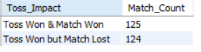

OUTPUT

Step 1: Consider only completed matches
- We filtered matches using Outcome_type = 1 to include only matches with a clear result.
- This avoids misleading conclusions from abandoned, tied, or no-result matches.
Step 2: Compare toss winner with match winner
- We checked whether the team that won the toss also won the match.
- Matches were classified into two categories:
  - Toss Won & Match Won
  - Toss Won but Match Lost
Step 3: Aggregate match counts
- We counted the number of matches in each category to understand the overall trend.
- This aggregation helps identify whether winning the toss consistently leads to winning the match.

Match: Won-Loss Counts

Conclusion:
The results show an almost equal distribution between matches won and lost after winning the toss (125 vs 124). This indicates that winning the toss does not significantly increase the chances of winning the match in this dataset. Therefore, at an overall level, the toss does not act as a decisive factor in determining match outcomes.

II. Impact of toss decision (Bat vs Field): Even if winning the toss does not strongly influence match outcomes overall, the decision taken after winning the toss (batting first or fielding first) may still affect the result.
This analysis is required to determine whether one toss decision provides a higher chance of winning compared to the other, thereby identifying strategic advantages in toss choices.
SELECT
Toss_Decide,
COUNT(*) AS Matches,
SUM(CASE WHEN Toss_Winner = Match_Winner THEN 1 ELSE 0 END) AS Toss_Win_Match_Win,
ROUND(
SUM(CASE WHEN Toss_Winner = Match_Winner THEN 1 ELSE 0 END) * 100.0 / COUNT(*),
2
) AS Win_Percentage
FROM matches
WHERE Outcome_type = 1
GROUP BY Toss_Decide;

SELECT
Toss_Decide,
COUNT(*) AS Matches,
SUM(CASE WHEN Toss_Winner = Match_Winner THEN 1 ELSE 0 END) AS Toss_Win_Match_Win,
ROUND(
SUM(CASE WHEN Toss_Winner = Match_Winner THEN 1 ELSE 0 END) * 100.0 / COUNT(*),
2
) AS Win_Percentage
FROM matches
WHERE Outcome_type = 1
GROUP BY Toss_Decide;

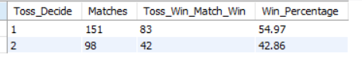
OUTPUT
Step 1: Filter completed matches
Only matches with Outcome_type = 1 were included to ensure reliable match results.
Step 2: Group by toss decision
Matches were grouped based on Toss_Decide:
- 1 → Bat first
- 2 → Field first
Step 3: Calculate win percentage after winning the toss
For each toss decision:
- Total matches were counted
- Matches where the toss winner also won the match were counted
- Win percentage was calculated to quantify the effectiveness of each decision

Conclusion:
The results indicate that teams choosing to bat first after winning the toss achieved a higher win percentage (54.97%) compared to teams choosing to field first (42.86%). This suggests that, in this dataset, opting to bat first after winning the toss is associated with better match outcomes.
III. Venue-wise Toss Impact: While earlier analysis showed that winning the toss does not have a significant overall impact and that the effectiveness of a toss decision varies, these effects may be masked when data is aggregated across all venues.
Since pitch behavior, ground dimensions, and playing conditions differ by venue, it is necessary to analyze the toss decision impact at a venue level to identify whether the advantage of batting or fielding first is venue-specific rather than universal.
SELECT Venue_Id, Toss_Decide, COUNT(*) AS Matches,
ROUND(
SUM(CASE WHEN Toss_Winner = Match_Winner THEN 1 ELSE 0 END) * 100.0 / COUNT(*),
2
) AS Win_Percentage
FROM matches
WHERE Outcome_type = 1
GROUP BY Venue_Id, Toss_Decide
ORDER BY Venue_Id, Win_Percentage DESC;

SELECT Venue_Id, Toss_Decide, COUNT(*) AS Matches,
ROUND(
SUM(CASE WHEN Toss_Winner = Match_Winner THEN 1 ELSE 0 END) * 100.0 / COUNT(*),
2
) AS Win_Percentage
FROM matches
WHERE Outcome_type = 1
GROUP BY Venue_Id, Toss_Decide
ORDER BY Venue_Id, Win_Percentage DESC;

Step 1: Consider only completed matches
Only matches with Outcome_type = 1 were included to ensure valid results.
Step 2: Group by venue and toss decision
Matches were grouped using:
- Venue_Id
- Toss_Decide (Bat first / Field first)
Step 3: Compute win percentage
For each venue and toss decision combination:
- Total matches were counted
- Win percentage of toss-winning teams was calculated
This allows a direct comparison of toss effectiveness across venues.
Average of Win_Percentage | Column Labels
Row Labels | Bat First | Field First
1 | 54.17 | 33.33
2 | 54.55 | 50
3 | 66.67 | 42.86
4 | 41.67 | 64.29
5 | 62.5 | 30
6 | 75 | 25
7 | 60 | 16.67
8 | 25 | 72.73
18 | 33.33 | 100
19 | 25 | 33.33
20 | 66.67 | 0
22 | 0 | 0
25 | 40 | 50
26 | 0 | 57.14
27 | 66.67 | 33.33
28 | 75 | 33.33
29 | 66.67 | 66.67
30 | 50 | 0
31 | 50 | 33.33
32 | 66.67 | 50
33 | 40 | 0
34 | 66.67 | 0
35 | 100 | 0
OUTPUT

Win-Percentage Heatmap: -
Conclusion:
The venue-wise analysis shows that the impact of the toss decision is not consistent across all venues. While some venues favor batting first, others favor fielding first, and a few show negligible differences. This confirms that the effect of the toss decision is limited to specific venues and should be made based on venue conditions rather than a general strategy.
2. Suggest some of the players who would be best fit for the team.
A. The following analysis identifies players best suited for the team based on their consistent batting contributions, wicket-taking ability, and overall impact across recent seasons.

I. Top Batsmen (Total Runs + Strike Rate): This analysis focuses on identifying top-performing batsmen by evaluating their total runs and strike rate, ensuring the selection of players who not only score consistently but also maintain an effective scoring pace, which is crucial for building a strong and balanced team.
SELECT p.Player_Name,
SUM(bb.Runs_Scored) AS Total_Runs,
ROUND((SUM(bb.Runs_Scored)/COUNT(bb.Ball_Id))*100,2) AS Strike_Rate
FROM ball_by_ball bb
JOIN matches m ON bb.Match_Id=m.Match_Id
JOIN player p ON bb.Striker=p.Player_Id
WHERE m.Outcome_type=1
GROUP BY p.Player_Name
HAVING COUNT(DISTINCT m.Match_Id)>=20
ORDER BY Total_Runs DESC;

SELECT p.Player_Name,
SUM(bb.Runs_Scored) AS Total_Runs,
ROUND((SUM(bb.Runs_Scored)/COUNT(bb.Ball_Id))*100,2) AS Strike_Rate
FROM ball_by_ball bb
JOIN matches m ON bb.Match_Id=m.Match_Id
JOIN player p ON bb.Striker=p.Player_Id
WHERE m.Outcome_type=1
GROUP BY p.Player_Name
HAVING COUNT(DISTINCT m.Match_Id)>=20
ORDER BY Total_Runs DESC;

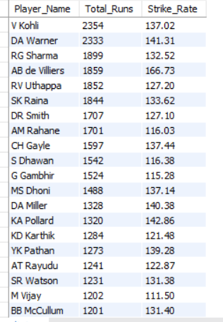
OUTPUT

a. Consider only completed matches (Outcome_type = 1) to ensure valid performance evaluation.
b. Aggregate batting performance by player using Striker to capture individual run contributions.
c. Calculate Total Runs to measure overall consistency and volume of scoring.
d. Compute Strike Rate to assess scoring efficiency and impact.
e. Filter players with a minimum match threshold (≥ 20 matches) to avoid skewed results from small samples.
f. Rank players by Total Runs to identify the most reliable top-order batsmen.

Conclusion:
The visualization highlights a clear group of batsmen who combine high total run accumulation with strong strike rates, indicating both consistency and scoring impact. Players at the top of the chart deliver sustained run production while maintaining efficient scoring, making them reliable anchors and aggressive contributors for the team. As the total runs decline toward the right, strike rates also generally taper, suggesting reduced overall impact. Therefore, players positioned in the upper-left segment of the chart represent the best batting fit, as they balance longevity, consistency, and scoring efficiency—key attributes for building a competitive and stable team batting lineup.

II. Top Bowlers (Total Wickets + Avg Wickets): This analysis was performed to identify the most effective bowlers by evaluating both their total wicket-taking ability and their consistency across matches. While total wickets indicate long-term impact, average wickets per match highlight reliability and match-winning potential, which are critical for selecting bowlers who can consistently influence outcomes.
SELECT p.Player_Name,
COUNT(wt.Player_Out) AS Total_Wickets,
COUNT(DISTINCT m.Match_Id) AS Matches_Played,
ROUND(COUNT(wt.Player_Out)/COUNT(DISTINCT m.Match_Id),2) AS Avg_Wickets_Per_Match
FROM wicket_taken wt
JOIN ball_by_ball bb
ON wt.Match_Id=bb.Match_Id
AND wt.Innings_No=bb.Innings_No
AND wt.Over_Id=bb.Over_Id
AND wt.Ball_Id=bb.Ball_Id
JOIN matches m
ON bb.Match_Id=m.Match_Id
JOIN player p
ON bb.Bowler=p.Player_Id
WHERE m.Outcome_type=1
AND m.Season_Id BETWEEN 6 AND 9
GROUP BY p.Player_Name
HAVING COUNT(wt.Player_Out)>=30
ORDER BY Total_Wickets DESC;

SELECT p.Player_Name,
COUNT(wt.Player_Out) AS Total_Wickets,
COUNT(DISTINCT m.Match_Id) AS Matches_Played,
ROUND(COUNT(wt.Player_Out)/COUNT(DISTINCT m.Match_Id),2) AS Avg_Wickets_Per_Match
FROM wicket_taken wt
JOIN ball_by_ball bb
ON wt.Match_Id=bb.Match_Id
AND wt.Innings_No=bb.Innings_No
AND wt.Over_Id=bb.Over_Id
AND wt.Ball_Id=bb.Ball_Id
JOIN matches m
ON bb.Match_Id=m.Match_Id
JOIN player p
ON bb.Bowler=p.Player_Id
WHERE m.Outcome_type=1
AND m.Season_Id BETWEEN 6 AND 9
GROUP BY p.Player_Name
HAVING COUNT(wt.Player_Out)>=30
ORDER BY Total_Wickets DESC;

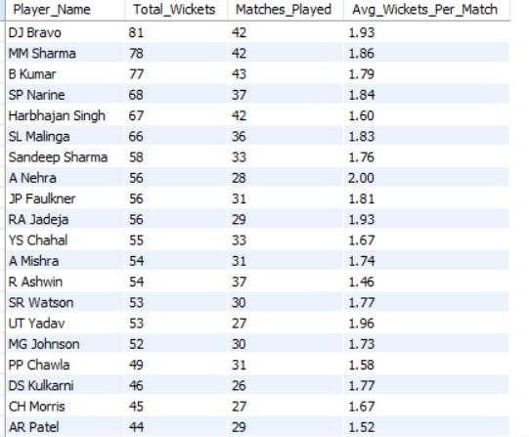
OUTPUT

- Consider only completed matches (Outcome_type = 1) to ensure valid performance measurement.
- Use wicket_taken as the primary table to accurately capture wicket events.
- Join with ball_by_ball using full ball identifiers to correctly map each wicket to the responsible bowler.
- Join with matches to filter performances within the required seasons (Season 6 to 9).
- Aggregate data at the player level to compute Total Wickets and Matches Played.
- Calculate Average Wickets per Match to assess consistency.
- Apply a minimum wicket threshold (≥ 30 wickets) to exclude low-impact or short-sample players.
- Rank bowlers by Total Wickets to identify the most impactful performers.

Conclusion:
The chart clearly distinguishes a group of bowlers who combine high total wickets with strong average wickets per match, indicating both durability and consistent match impact. Bowlers positioned at the top of the chart demonstrate sustained wicket-taking ability over multiple seasons, making them reliable strike options. As total wickets decrease, the average wickets per match also generally decline, suggesting reduced influence on match outcomes. Overall, bowlers appearing in the upper segment of the chart represent the best fit for the team, as they balance longevity, consistency, and wicket-taking effectiveness—key qualities for building a strong bowling attack.

3. What are some of the parameters that should be focused on while selecting the players?
A. To identify the right players for team selection, past performance data provides the most reliable evidence. Hence, the analysis focuses on players’ performances over the last 4 seasons (Season 6–9). Separate performance parameters are defined for bowlers and batsmen, and SQL queries are used to validate each parameter quantitatively.
I. Parameters for Selecting Best Bowlers
The most important parameters for bowlers are:
- Bowling Average – Runs conceded per wicket; lower values indicate effectiveness.
- Economy Rate – Runs conceded per over; lower values indicate control.
- Strike Rate (Bowling) – Balls bowled per wicket; lower values indicate wicket-taking frequency.
SELECT
p.Player_Name,
COUNT(bb.Ball_Id) AS Total_Balls_Bowled,
COUNT(wt.Player_Out) AS Total_Wickets_Taken,
ROUND(SUM(bb.Runs_Scored)/COUNT(wt.Player_Out),2) AS Bowling_Average,
ROUND(SUM(bb.Runs_Scored)/(COUNT(bb.Ball_Id)/6),2) AS Economy_Rate,
ROUND(COUNT(bb.Ball_Id)/COUNT(wt.Player_Out),2) AS Strike_Rate
FROM ball_by_ball bb
LEFT JOIN wicket_taken wt
ON bb.Match_Id=wt.Match_Id
AND bb.Innings_No=wt.Innings_No
AND bb.Over_Id=wt.Over_Id
AND bb.Ball_Id=wt.Ball_Id
JOIN matches m
ON bb.Match_Id=m.Match_Id
JOIN player p
ON bb.Bowler=p.Player_Id
WHERE m.Outcome_type=1
AND m.Season_Id BETWEEN 6 AND 9
GROUP BY p.Player_Name
HAVING
COUNT(wt.Player_Out)>30
AND ROUND(SUM(bb.Runs_Scored)/COUNT(wt.Player_Out),2)<25
AND ROUND(SUM(bb.Runs_Scored)/(COUNT(bb.Ball_Id)/6),2)<10
AND ROUND(COUNT(bb.Ball_Id)/COUNT(wt.Player_Out),2)<20
ORDER BY Total_Wickets_Taken DESC;

SELECT
p.Player_Name,
COUNT(bb.Ball_Id) AS Total_Balls_Bowled,
COUNT(wt.Player_Out) AS Total_Wickets_Taken,
ROUND(SUM(bb.Runs_Scored)/COUNT(wt.Player_Out),2) AS Bowling_Average,
ROUND(SUM(bb.Runs_Scored)/(COUNT(bb.Ball_Id)/6),2) AS Economy_Rate,
ROUND(COUNT(bb.Ball_Id)/COUNT(wt.Player_Out),2) AS Strike_Rate
FROM ball_by_ball bb
LEFT JOIN wicket_taken wt
ON bb.Match_Id=wt.Match_Id
AND bb.Innings_No=wt.Innings_No
AND bb.Over_Id=wt.Over_Id
AND bb.Ball_Id=wt.Ball_Id
JOIN matches m
ON bb.Match_Id=m.Match_Id
JOIN player p
ON bb.Bowler=p.Player_Id
WHERE m.Outcome_type=1
AND m.Season_Id BETWEEN 6 AND 9
GROUP BY p.Player_Name
HAVING
COUNT(wt.Player_Out)>30
AND ROUND(SUM(bb.Runs_Scored)/COUNT(wt.Player_Out),2)<25
AND ROUND(SUM(bb.Runs_Scored)/(COUNT(bb.Ball_Id)/6),2)<10
AND ROUND(COUNT(bb.Ball_Id)/COUNT(wt.Player_Out),2)<20
ORDER BY Total_Wickets_Taken DESC;

OUTPUT
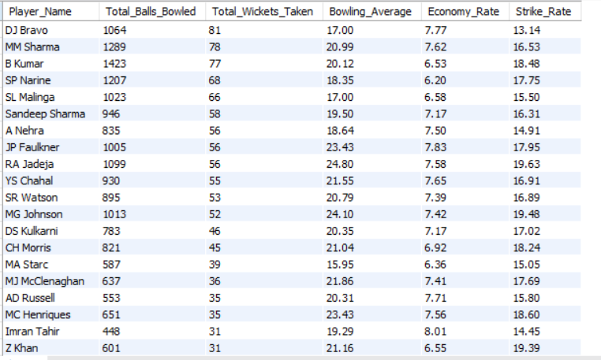
Insight:
This query filters bowlers who consistently take wickets while maintaining control over runs, identifying high-impact and reliable bowlers.
II. Parameters for Selecting Best Batsmen
The most important parameters for batsmen are:
- Total Runs Scored – Measures consistency and longevity.
- Batting Average – Runs scored per dismissal; higher values indicate reliability.
- Strike Rate – Scoring efficiency; higher values indicate attacking ability.
OUTPUT
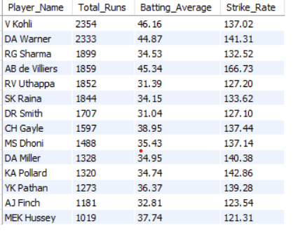
SELECT
p.Player_Name,
SUM(bb.Runs_Scored) AS Total_Runs,
ROUND(SUM(bb.Runs_Scored)/COUNT(wt.Player_Out),2) AS Batting_Average,
ROUND((SUM(bb.Runs_Scored)/COUNT(bb.Ball_Id))*100,2) AS Strike_Rate
FROM ball_by_ball bb
LEFT JOIN wicket_taken wt
ON bb.Match_Id=wt.Match_Id
AND bb.Innings_No=wt.Innings_No
AND bb.Over_Id=wt.Over_Id
AND bb.Ball_Id=wt.Ball_Id
JOIN matches m ON bb.Match_Id=m.Match_Id
JOIN player p ON bb.Striker=p.Player_Id
WHERE m.Outcome_type=1
AND m.Season_Id BETWEEN 6 AND 9
GROUP BY p.Player_Name
HAVING
Total_Runs>1000
AND Batting_Average>30
AND Strike_Rate>120
ORDER BY Total_Runs DESC,Batting_Average DESC,Strike_Rate DESC;

SELECT
p.Player_Name,
SUM(bb.Runs_Scored) AS Total_Runs,
ROUND(SUM(bb.Runs_Scored)/COUNT(wt.Player_Out),2) AS Batting_Average,
ROUND((SUM(bb.Runs_Scored)/COUNT(bb.Ball_Id))*100,2) AS Strike_Rate
FROM ball_by_ball bb
LEFT JOIN wicket_taken wt
ON bb.Match_Id=wt.Match_Id
AND bb.Innings_No=wt.Innings_No
AND bb.Over_Id=wt.Over_Id
AND bb.Ball_Id=wt.Ball_Id
JOIN matches m ON bb.Match_Id=m.Match_Id
JOIN player p ON bb.Striker=p.Player_Id
WHERE m.Outcome_type=1
AND m.Season_Id BETWEEN 6 AND 9
GROUP BY p.Player_Name
HAVING
Total_Runs>1000
AND Batting_Average>30
AND Strike_Rate>120
ORDER BY Total_Runs DESC,Batting_Average DESC,Strike_Rate DESC;

Insight:
This query identifies batsmen who score consistently, stay longer at the crease, and maintain a high scoring rate.

III. Situational Performance:
Powerplay performance of players was evaluated using a single query by simultaneously analyzing batting impact and bowling effectiveness during overs 1–6.
Players who perform well under high-pressure phases add strategic value to the team.
- For batsmen
Powerplay runs
  - Powerplay strike rate
- For bowlers
  - Powerplay wickets
  - Powerplay economy
All restricted to:
- Powerplay overs only (1–6)
- Last 4 seasons
- Completed matches

SELECT
p.Player_Name,
SUM(bb.Runs_Scored) AS Powerplay_Runs,
ROUND((SUM(bb.Runs_Scored)/COUNT(bb.Ball_Id))*100,2) AS Powerplay_Strike_Rate,
COUNT(wt.Player_Out) AS Powerplay_Wickets,
ROUND(SUM(bb.Runs_Scored) /NULLIF((COUNT(bb.Ball_Id)/6),0),2) AS Powerplay_Economy
FROM ball_by_ball bb
LEFT JOIN wicket_taken wt
ON bb.Match_Id=wt.Match_Id
AND bb.Innings_No=wt.Innings_No
AND bb.Over_Id=wt.Over_Id
AND bb.Ball_Id=wt.Ball_Id
JOIN matches m
ON bb.Match_Id=m.Match_Id
JOIN player p
ON p.Player_Id IN (bb.Striker,bb.Bowler)
WHERE m.Outcome_type=1
AND m.Season_Id BETWEEN 6 AND 9
AND bb.Over_Id BETWEEN 1 AND 6
GROUP BY p.Player_Id,p.Player_Name
ORDER BY Powerplay_Runs DESC,Powerplay_Wickets DESC;

SELECT
p.Player_Name,
SUM(bb.Runs_Scored) AS Powerplay_Runs,
ROUND((SUM(bb.Runs_Scored)/COUNT(bb.Ball_Id))*100,2) AS Powerplay_Strike_Rate,
COUNT(wt.Player_Out) AS Powerplay_Wickets,
ROUND(SUM(bb.Runs_Scored) /NULLIF((COUNT(bb.Ball_Id)/6),0),2) AS Powerplay_Economy
FROM ball_by_ball bb
LEFT JOIN wicket_taken wt
ON bb.Match_Id=wt.Match_Id
AND bb.Innings_No=wt.Innings_No
AND bb.Over_Id=wt.Over_Id
AND bb.Ball_Id=wt.Ball_Id
JOIN matches m
ON bb.Match_Id=m.Match_Id
JOIN player p
ON p.Player_Id IN (bb.Striker,bb.Bowler)
WHERE m.Outcome_type=1
AND m.Season_Id BETWEEN 6 AND 9
AND bb.Over_Id BETWEEN 1 AND 6
GROUP BY p.Player_Id,p.Player_Name
ORDER BY Powerplay_Runs DESC,Powerplay_Wickets DESC;

OUTPUT
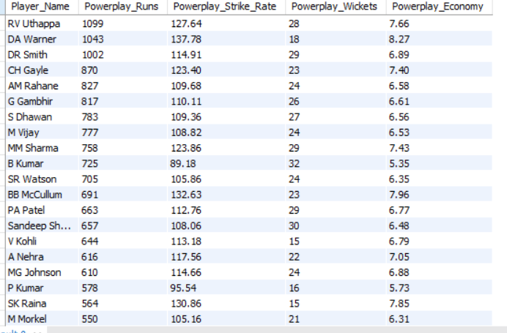

Insight:
Situational performance was analyzed by evaluating player effectiveness during powerplay and death overs, identifying batsmen who score efficiently under field restrictions and bowlers who maintain control in high-pressure phases.

4. Which players offer versatility in their skills and can contribute effectively with both bat and ball? (can you visualize the data for the same)
A. To identify effective all-rounders, player performance is analyzed only across the last four seasons (Season 6–9) rather than the entire career. This approach focuses on recent and relevant form, ensuring that selected players demonstrate current batting efficiency and bowling effectiveness, which is more reliable for present team selection than historical performance alone.
- Filter match data to include only completed matches (Outcome_type = 1) to ensure valid performance evaluation.
- Restrict the analysis to Season 6–9 to capture recent performance trends rather than entire career statistics.
- Aggregate batting performance for each player by calculating:
- Total runs scored
- Batting strike rate (runs per ball × 100)
- Aggregate bowling performance for each player by calculating:
- Total wickets taken
- Bowling strike rate (balls bowled per wicket)
- Join batting and bowling aggregates at the player level to identify players contributing in both disciplines.
- Apply performance thresholds to ensure meaningful dual contribution:
- Batting Strike Rate ≥ 100
- Bowling Strike Rate ≤ 40
- Total Wickets Taken ≥ 15
- Rank the shortlisted players by batting contribution first and bowling impact next to highlight the most valuable all-rounders.

WITH batting_data AS (
SELECT bb.Striker AS Player_Id, p.Player_Name,
SUM(bb.Runs_Scored) AS Total_Runs_Scored,
ROUND((SUM(bb.Runs_Scored)/COUNT(bb.Ball_Id))*100,2) AS Batting_Strike_Rate
FROM ball_by_ball bb
JOIN matches m ON bb.Match_Id = m.Match_Id
JOIN player p ON bb.Striker = p.Player_Id
WHERE m.Outcome_type = 1
AND m.Season_Id BETWEEN 6 AND 9
GROUP BY bb.Striker,p.Player_Name
),
bowling_data AS (
SELECT bb.Bowler AS Player_Id, p.Player_Name,
COUNT(wt.Player_Out) AS Total_Wickets_Taken,
ROUND(COUNT(bb.Ball_Id)/COUNT(wt.Player_Out),2) AS Bowling_Strike_Rate
FROM ball_by_ball bb
LEFT JOIN wicket_taken wt ON bb.Match_Id = wt.Match_Id
AND bb.Innings_No = wt.Innings_No
AND bb.Over_Id = wt.Over_Id
AND bb.Ball_Id = wt.Ball_Id
JOIN matches m ON bb.Match_Id = m.Match_Id
JOIN player p ON bb.Bowler = p.Player_Id
WHERE m.Outcome_type = 1
AND m.Season_Id BETWEEN 6 AND 9
GROUP BY bb.Bowler,p.Player_Name
)
SELECT
b.Player_Id,
b.Player_Name,
b.Total_Runs_Scored,
b.Batting_Strike_Rate,
bw.Total_Wickets_Taken,
bw.Bowling_Strike_Rate
FROM batting_data b
JOIN bowling_data bw
ON b.Player_Id = bw.Player_Id
WHERE
b.Batting_Strike_Rate >= 100
AND bw.Bowling_Strike_Rate <= 40
AND bw.Total_Wickets_Taken >= 15
ORDER BY b.Total_Runs_Scored DESC,bw.Total_Wickets_Taken DESC
LIMIT 20;

WITH batting_data AS (
SELECT bb.Striker AS Player_Id, p.Player_Name,
SUM(bb.Runs_Scored) AS Total_Runs_Scored,
ROUND((SUM(bb.Runs_Scored)/COUNT(bb.Ball_Id))*100,2) AS Batting_Strike_Rate
FROM ball_by_ball bb
JOIN matches m ON bb.Match_Id = m.Match_Id
JOIN player p ON bb.Striker = p.Player_Id
WHERE m.Outcome_type = 1
AND m.Season_Id BETWEEN 6 AND 9
GROUP BY bb.Striker,p.Player_Name
),
bowling_data AS (
SELECT bb.Bowler AS Player_Id, p.Player_Name,
COUNT(wt.Player_Out) AS Total_Wickets_Taken,
ROUND(COUNT(bb.Ball_Id)/COUNT(wt.Player_Out),2) AS Bowling_Strike_Rate
FROM ball_by_ball bb
LEFT JOIN wicket_taken wt ON bb.Match_Id = wt.Match_Id
AND bb.Innings_No = wt.Innings_No
AND bb.Over_Id = wt.Over_Id
AND bb.Ball_Id = wt.Ball_Id
JOIN matches m ON bb.Match_Id = m.Match_Id
JOIN player p ON bb.Bowler = p.Player_Id
WHERE m.Outcome_type = 1
AND m.Season_Id BETWEEN 6 AND 9
GROUP BY bb.Bowler,p.Player_Name
)
SELECT
b.Player_Id,
b.Player_Name,
b.Total_Runs_Scored,
b.Batting_Strike_Rate,
bw.Total_Wickets_Taken,
bw.Bowling_Strike_Rate
FROM batting_data b
JOIN bowling_data bw
ON b.Player_Id = bw.Player_Id
WHERE
b.Batting_Strike_Rate >= 100
AND bw.Bowling_Strike_Rate <= 40
AND bw.Total_Wickets_Taken >= 15
ORDER BY b.Total_Runs_Scored DESC,bw.Total_Wickets_Taken DESC
LIMIT 20;

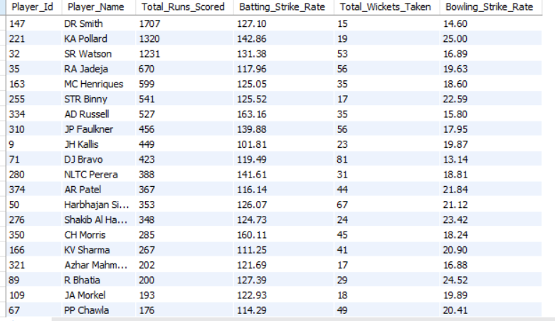
OUTPUT

Summarize:
The visualization highlights players who make meaningful contributions with both bat and ball, as reflected by a high batting strike rate and a low bowling strike rate. Players positioned with strong batting strike rates (right side) and efficient bowling strike rates (shorter bars on the left) demonstrate true all-round value. The chart shows that only a limited group of players achieve this balance, indicating that versatility is relatively rare. These players enhance team flexibility by contributing across multiple match situations, reducing dependence on specialists and strengthening overall team balance.

5. Are there players whose presence positively influences the morale and performance of the team? (justify your answer using visualization)
A. Team morale and on-field influence cannot be measured directly, but they can be inferred through consistent match-winning performances, individual impact in victories, and repeated recognition in high-pressure situations. Therefore, player influence is evaluated by analyzing performance patterns in winning matches and visualizing their contribution to team success.
I. Players with High Impact in Winning Matches: To understand whether certain players positively influence team performance, it is important to analyze how much they contribute specifically in matches that the team wins. Players who consistently score a high number of runs across many winning matches are more likely to drive match outcomes, create momentum, and positively influence team morale, rather than contributing in isolated or losing situations.
- Consider only matches that resulted in a win to align individual performance with team success.
- Aggregate runs scored by each player exclusively in winning matches.
- Count the number of matches won in which each player contributed to ensure consistency and not one-off performances.
- Filter players with a minimum number of winning matches to remove occasional or low-impact contributors.
- Rank players by runs scored in winning matches to identify those with the strongest influence on victories.
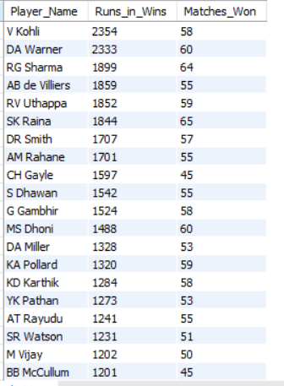
OUTPUT

SELECT
p.Player_Name,
SUM(bb.Runs_Scored) AS Runs_in_Wins,
COUNT(DISTINCT m.Match_Id) AS Matches_Won
FROM ball_by_ball bb
JOIN matches m ON bb.Match_Id=m.Match_Id
JOIN player p ON bb.Striker=p.Player_Id
WHERE m.Outcome_type=1
GROUP BY p.Player_Name
HAVING Matches_Won>=20
ORDER BY Runs_in_Wins DESC;

SELECT
p.Player_Name,
SUM(bb.Runs_Scored) AS Runs_in_Wins,
COUNT(DISTINCT m.Match_Id) AS Matches_Won
FROM ball_by_ball bb
JOIN matches m ON bb.Match_Id=m.Match_Id
JOIN player p ON bb.Striker=p.Player_Id
WHERE m.Outcome_type=1
GROUP BY p.Player_Name
HAVING Matches_Won>=20
ORDER BY Runs_in_Wins DESC;

Summarize:
The chart shows that players positioned at the top contribute substantially higher runs in winning matches and are involved in more team victories compared to others. There is a clear declining trend as we move down the chart, where both Runs in Wins and Matches Won reduce steadily. This indicates that team success is driven by a small set of core players, while the remaining players have comparatively lower influence on match outcomes. Overall, the visualization highlights that consistent run contributions in winning matches are concentrated among a few key players, reinforcing their strong impact on team performance and morale.

II. Man of the Match as a Morale Indicator: Man of the Match awards represent direct match-winning impact, often under pressure situations. Analyzing players with multiple such awards helps identify individuals whose performances consistently influence match outcomes and positively affect team confidence and morale.
- Use match-level data to identify the Man of the Match winner for each completed match.
- Aggregate the count of Man of the Match awards per player across all matches.
- Rank players by total Man of the Match count to highlight repeated high-impact performers.
- Focus on players with multiple awards to ensure consistency rather than one-time impact.
- Visualize the top players to clearly compare individual influence.
SELECT p.Player_Name,
COUNT(m.Man_of_the_Match) AS MOTM_Count
FROM matches m
JOIN player p ON m.Man_of_the_Match=p.Player_Id
GROUP BY p.Player_Name
ORDER BY MOTM_Count DESC;

SELECT p.Player_Name,
COUNT(m.Man_of_the_Match) AS MOTM_Count
FROM matches m
JOIN player p ON m.Man_of_the_Match=p.Player_Id
GROUP BY p.Player_Name
ORDER BY MOTM_Count DESC;
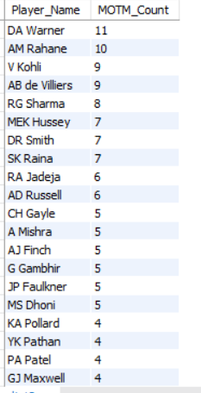
OUTPUT

Summarize:
The chart shows that a small group of players have won the Man of the Match award multiple times, clearly standing out from others. Players at the top of the chart demonstrate repeated match-defining performances, while the gradual decline across players indicates diminishing influence. This concentration of awards suggests that team success and momentum are often driven by a few high-impact individuals, whose consistent contributions are likely to boost overall team morale and performance.

III. Performance Comparison: Wins vs Losses: To assess whether certain players positively influence team performance, it is necessary to compare their contributions in winning matches versus losing matches. Players whose performances are significantly stronger in wins are more likely to be drivers of success and contributors to team confidence and morale.
- Separate player batting contributions into runs scored in winning matches and runs scored in losing matches.
- Compute the Impact Difference for each player to quantify how strongly their performance aligns with victories.
- Shortlist top players based on higher impact difference to focus on meaningful contributors.
- Visualize all three measures together to allow direct comparison of performance in wins, losses, and overall influence.
SELECT
p.Player_Name,
SUM(CASE WHEN m.Outcome_type=1 THEN bb.Runs_Scored ELSE 0 END) AS Runs_in_Wins,
SUM(CASE WHEN m.Outcome_type<>1 THEN bb.Runs_Scored ELSE 0 END) AS Runs_in_Losses
FROM ball_by_ball bb
JOIN matches m ON bb.Match_Id=m.Match_Id
JOIN player p ON bb.Striker=p.Player_Id
GROUP BY p.Player_Name
HAVING Runs_in_Wins > Runs_in_Losses
ORDER BY Runs_in_Wins DESC
LIMIT 15;

SELECT
p.Player_Name,
SUM(CASE WHEN m.Outcome_type=1 THEN bb.Runs_Scored ELSE 0 END) AS Runs_in_Wins,
SUM(CASE WHEN m.Outcome_type<>1 THEN bb.Runs_Scored ELSE 0 END) AS Runs_in_Losses
FROM ball_by_ball bb
JOIN matches m ON bb.Match_Id=m.Match_Id
JOIN player p ON bb.Striker=p.Player_Id
GROUP BY p.Player_Name
HAVING Runs_in_Wins > Runs_in_Losses
ORDER BY Runs_in_Wins DESC
LIMIT 15;

OUTPUT
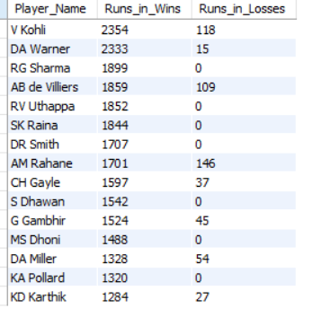

Summarize:
The chart shows that for the selected players, runs scored in winning matches are significantly higher than runs scored in losing matches, resulting in a large positive impact difference. This pattern is consistent across the top players, indicating that their performances are closely associated with team victories rather than isolated contributions in losses. Players with the largest gaps between wins and losses emerge as high-impact performers, whose contributions are most strongly linked to successful outcomes and, by extension, positive team morale.

6. What would you suggest to RCB before going to the mega auction?
A. A mega auction presents an opportunity for a complete squad reset, making it essential for RCB to adopt a data-driven and impact-focused strategy rather than relying on reputation or past associations. The approach should be divided into two key objectives: retaining proven RCB performers and targeting high-impact players from across the league who can strengthen the squad’s balance and match-winning ability.

1. RCB Player Retention Strategy
Since retention slots are limited, RCB should prioritize players who have consistently contributed to the team’s success rather than those with isolated performances.
a. High Runs_in_Wins for RCB:
Players who score heavily in matches that RCB wins demonstrate a strong alignment with team success. Such players tend to stabilize innings, build momentum, and perform under pressure. Retaining these players ensures continuity and preserves RCB’s core match-winning strength.
SELECT
p.Player_Name,
SUM(bb.Runs_Scored) AS Runs_in_Wins,
COUNT(DISTINCT m.Match_Id) AS Matches_Won
FROM ball_by_ball bb
JOIN matches m
ON bb.Match_Id = m.Match_Id
JOIN player p
ON bb.Striker = p.Player_Id
WHERE
m.Outcome_type = 1
AND bb.Team_Batting = ( SELECT Team_Id
FROM team
WHERE Team_Name = 'Royal Challengers Bangalore' )
GROUP BY p.Player_Name
HAVING COUNT(DISTINCT m.Match_Id) >= 10
ORDER BY Runs_in_Wins DESC;

SELECT
p.Player_Name,
SUM(bb.Runs_Scored) AS Runs_in_Wins,
COUNT(DISTINCT m.Match_Id) AS Matches_Won
FROM ball_by_ball bb
JOIN matches m
ON bb.Match_Id = m.Match_Id
JOIN player p
ON bb.Striker = p.Player_Id
WHERE
m.Outcome_type = 1
AND bb.Team_Batting = ( SELECT Team_Id
FROM team
WHERE Team_Name = 'Royal Challengers Bangalore' )
GROUP BY p.Player_Name
HAVING COUNT(DISTINCT m.Match_Id) >= 10
ORDER BY Runs_in_Wins DESC;

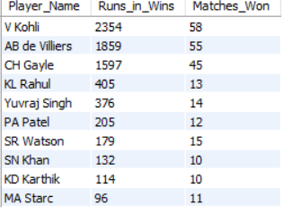
OUTPUT

b. Man of the Match from RCB:
Players with multiple Man of the Match awards for RCB reflect repeated match-defining impact. These individuals often influence both outcomes and team morale through leadership and clutch performances. Retaining such players helps maintain a confident and competitive team environment.
SELECT
p.Player_Name,
COUNT(m.Man_of_the_Match) AS MOTM_Count
FROM matches m
JOIN player p ON m.Man_of_the_Match = p.Player_Id
JOIN team t ON m.Match_Winner = t.Team_Id
WHERE t.Team_Name = 'Royal Challengers Bangalore'
GROUP BY p.Player_Name
ORDER BY MOTM_Count DESC;

SELECT
p.Player_Name,
COUNT(m.Man_of_the_Match) AS MOTM_Count
FROM matches m
JOIN player p ON m.Man_of_the_Match = p.Player_Id
JOIN team t ON m.Match_Winner = t.Team_Id
WHERE t.Team_Name = 'Royal Challengers Bangalore'
GROUP BY p.Player_Name
ORDER BY MOTM_Count DESC;
OUTPUT

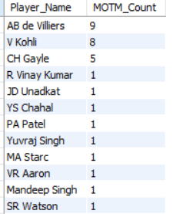

c. All-rounder of RCB:
RCB should retain genuine all-rounders who contribute meaningfully with both bat and ball. These players provide flexibility in team combinations, reduce dependency on specialists, and enhance adaptability across match situations.
OUTPUT
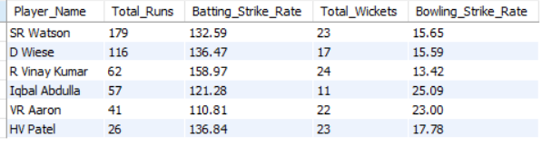

WITH batting_data AS (
SELECT bb.Striker AS Player_Id, p.Player_Name,
SUM(bb.Runs_Scored) AS Total_Runs,
ROUND((SUM(bb.Runs_Scored)/COUNT(bb.Ball_Id))*100,2) AS Batting_Strike_Rate
FROM ball_by_ball bb
JOIN matches m ON bb.Match_Id=m.Match_Id
JOIN player p ON bb.Striker=p.Player_Id
WHERE m.Outcome_type=1 AND bb.Team_Batting=(
SELECT Team_Id FROM team WHERE Team_Name='Royal Challengers Bangalore' )
GROUP BY bb.Striker,p.Player_Nam),
bowling_data AS (
SELECT bb.Bowler AS Player_Id, p.Player_Name,
COUNT(wt.Player_Out) AS Total_Wickets,
ROUND(COUNT(bb.Ball_Id)/NULLIF(COUNT(wt.Player_Out),0),2) AS Bowling_Strike_Rate
FROM ball_by_ball bb
LEFT JOIN wicket_taken wt
ON bb.Match_Id=wt.Match_Id
AND bb.Innings_No=wt.Innings_No
AND bb.Over_Id=wt.Over_Id
AND bb.Ball_Id=wt.Ball_Id
JOIN matches m ON bb.Match_Id=m.Match_Id
JOIN player p ON bb.Bowler=p.Player_Id
WHERE m.Outcome_type=1
AND bb.Team_Bowling=(SELECT Team_Id FROM team WHERE Team_Name='Royal Challengers Bangalore')
GROUP BY bb.Bowler,p.Player_Name
)
SELECT b.Player_Name, b.Total_Runs, b.Batting_Strike_Rate, bw.Total_Wickets,
bw.Bowling_Strike_Rate
FROM batting_data b
JOIN bowling_data bw ON b.Player_Id=bw.Player_Id
WHERE b.Batting_Strike_Rate>=100
AND bw.Bowling_Strike_Rate<=40
AND bw.Total_Wickets>=10
ORDER BY b.Total_Runs DESC,bw.Total_Wickets DESC;

WITH batting_data AS (
SELECT bb.Striker AS Player_Id, p.Player_Name,
SUM(bb.Runs_Scored) AS Total_Runs,
ROUND((SUM(bb.Runs_Scored)/COUNT(bb.Ball_Id))*100,2) AS Batting_Strike_Rate
FROM ball_by_ball bb
JOIN matches m ON bb.Match_Id=m.Match_Id
JOIN player p ON bb.Striker=p.Player_Id
WHERE m.Outcome_type=1 AND bb.Team_Batting=(
SELECT Team_Id FROM team WHERE Team_Name='Royal Challengers Bangalore' )
GROUP BY bb.Striker,p.Player_Nam),
bowling_data AS (
SELECT bb.Bowler AS Player_Id, p.Player_Name,
COUNT(wt.Player_Out) AS Total_Wickets,
ROUND(COUNT(bb.Ball_Id)/NULLIF(COUNT(wt.Player_Out),0),2) AS Bowling_Strike_Rate
FROM ball_by_ball bb
LEFT JOIN wicket_taken wt
ON bb.Match_Id=wt.Match_Id
AND bb.Innings_No=wt.Innings_No
AND bb.Over_Id=wt.Over_Id
AND bb.Ball_Id=wt.Ball_Id
JOIN matches m ON bb.Match_Id=m.Match_Id
JOIN player p ON bb.Bowler=p.Player_Id
WHERE m.Outcome_type=1
AND bb.Team_Bowling=(SELECT Team_Id FROM team WHERE Team_Name='Royal Challengers Bangalore')
GROUP BY bb.Bowler,p.Player_Name
)
SELECT b.Player_Name, b.Total_Runs, b.Batting_Strike_Rate, bw.Total_Wickets,
bw.Bowling_Strike_Rate
FROM batting_data b
JOIN bowling_data bw ON b.Player_Id=bw.Player_Id
WHERE b.Batting_Strike_Rate>=100
AND bw.Bowling_Strike_Rate<=40
AND bw.Total_Wickets>=10
ORDER BY b.Total_Runs DESC,bw.Total_Wickets DESC;

2. Identifying League-Wide High-Impact Players (Auction Targets)
Since a mega auction opens access to the entire player pool, RCB must look beyond its current squad and target players who consistently influence match outcomes.

a. Performance in Winning Matches (Match-Winning Ability)
Players who perform strongly in winning matches across the league are reliable indicators of match-winning capability. Targeting such players increases the probability of acquiring individuals who can directly contribute to victories rather than accumulate statistics in losing causes.

SELECT
p.Player_Name,
SUM(bb.Runs_Scored) AS Runs_in_Wins,
COUNT(DISTINCT m.Match_Id) AS Matches_Won
FROM ball_by_ball bb
JOIN matches m ON bb.Match_Id=m.Match_Id
JOIN player p ON bb.Striker=p.Player_Id
WHERE
m.Outcome_type=1
AND bb.Team_Batting <> (
SELECT Team_Id FROM team WHERE Team_Name='Royal Challengers Bangalore'
)
GROUP BY p.Player_Name
HAVING COUNT(DISTINCT m.Match_Id)>=20
ORDER BY Runs_in_Wins DESC
limit 10;

SELECT
p.Player_Name,
SUM(bb.Runs_Scored) AS Runs_in_Wins,
COUNT(DISTINCT m.Match_Id) AS Matches_Won
FROM ball_by_ball bb
JOIN matches m ON bb.Match_Id=m.Match_Id
JOIN player p ON bb.Striker=p.Player_Id
WHERE
m.Outcome_type=1
AND bb.Team_Batting <> (
SELECT Team_Id FROM team WHERE Team_Name='Royal Challengers Bangalore'
)
GROUP BY p.Player_Name
HAVING COUNT(DISTINCT m.Match_Id)>=20
ORDER BY Runs_in_Wins DESC
limit 10;

OUTPUT
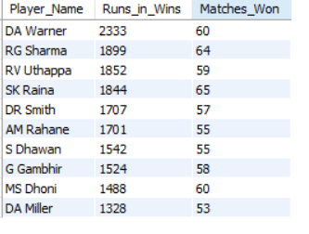

b. Impact Difference (Performance Alignment with Wins)
Impact difference measures how much better a player performs in wins compared to losses. Players with a high impact difference tend to elevate their game when it matters most, making them valuable assets in high-pressure scenarios common in tournaments like the IPL.

SELECT
p.Player_Name,
SUM(CASE WHEN m.Outcome_type=1 THEN bb.Runs_Scored ELSE 0 END) AS Runs_in_Wins,
SUM(CASE WHEN m.Outcome_type<>1 THEN bb.Runs_Scored ELSE 0 END) AS Runs_in_Losses,
SUM(CASE WHEN m.Outcome_type=1 THEN bb.Runs_Scored ELSE 0 END)-
SUM(CASE WHEN m.Outcome_type<>1 THEN bb.Runs_Scored ELSE 0 END) AS Impact_Difference
FROM ball_by_ball bb
JOIN matches m ON bb.Match_Id=m.Match_Id
JOIN player p ON bb.Striker=p.Player_Id
WHERE
bb.Team_Batting <> (
SELECT Team_Id FROM team WHERE Team_Name='Royal Challengers Bangalore'
)
GROUP BY p.Player_Name
HAVING Impact_Difference>0
ORDER BY Impact_Difference DESC
limit 10;

SELECT
p.Player_Name,
SUM(CASE WHEN m.Outcome_type=1 THEN bb.Runs_Scored ELSE 0 END) AS Runs_in_Wins,
SUM(CASE WHEN m.Outcome_type<>1 THEN bb.Runs_Scored ELSE 0 END) AS Runs_in_Losses,
SUM(CASE WHEN m.Outcome_type=1 THEN bb.Runs_Scored ELSE 0 END)-
SUM(CASE WHEN m.Outcome_type<>1 THEN bb.Runs_Scored ELSE 0 END) AS Impact_Difference
FROM ball_by_ball bb
JOIN matches m ON bb.Match_Id=m.Match_Id
JOIN player p ON bb.Striker=p.Player_Id
WHERE
bb.Team_Batting <> (
SELECT Team_Id FROM team WHERE Team_Name='Royal Challengers Bangalore'
)
GROUP BY p.Player_Name
HAVING Impact_Difference>0
ORDER BY Impact_Difference DESC
limit 10;

OUTPUT
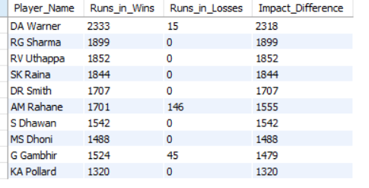

c. Versatility (Genuine All-Rounders)
Versatile players remain a premium asset in mega auctions. League-wide all-rounders who combine efficient batting with effective bowling provide greater tactical depth and better value for money, making them ideal auction targets.
WITH batting_data AS (
SELECT bb.Striker AS Player_Id, p.Player_Name,
SUM(bb.Runs_Scored) AS Total_Runs,
ROUND((SUM(bb.Runs_Scored)/COUNT(bb.Ball_Id))*100,2) AS Batting_Strike_Rate
FROM ball_by_ball bb
JOIN matches m ON bb.Match_Id=m.Match_Id
JOIN player p ON bb.Striker=p.Player_Id
WHERE m.Outcome_type=1
AND bb.Team_Batting <> (
SELECT Team_Id FROM team WHERE Team_Name='Royal Challengers Bangalore' )
GROUP BY bb.Striker,p.Player_Name),
bowling_data AS (
SELECT bb.Bowler AS Player_Id, p.Player_Name,
COUNT(wt.Player_Out) AS Total_Wickets,
ROUND(COUNT(bb.Ball_Id)/NULLIF(COUNT(wt.Player_Out),0),2) AS Bowling_Strike_Rate
FROM ball_by_ball bb
LEFT JOIN wicket_taken wt
ON bb.Match_Id=wt.Match_Id
AND bb.Innings_No=wt.Innings_No
AND bb.Over_Id=wt.Over_Id
AND bb.Ball_Id=wt.Ball_Id
JOIN matches m ON bb.Match_Id=m.Match_Id
JOIN player p ON bb.Bowler=p.Player_Id
WHERE m.Outcome_type=1
AND bb.Team_Bowling <> ( SELECT Team_Id FROM team WHERE Team_Name='Royal Challengers Bangalore' )
GROUP BY bb.Bowler,p.Player_Name)
SELECT b.Player_Name, b.Total_Runs, b.Batting_Strike_Rate, bw.Total_Wickets,
bw.Bowling_Strike_Rate
FROM batting_data b
JOIN bowling_data bw ON b.Player_Id=bw.Player_Id
WHERE b.Batting_Strike_Rate>=100
AND bw.Bowling_Strike_Rate<=40
AND bw.Total_Wickets>=15
ORDER BY b.Total_Runs DESC,bw.Total_Wickets DESC
limit 10;

WITH batting_data AS (
SELECT bb.Striker AS Player_Id, p.Player_Name,
SUM(bb.Runs_Scored) AS Total_Runs,
ROUND((SUM(bb.Runs_Scored)/COUNT(bb.Ball_Id))*100,2) AS Batting_Strike_Rate
FROM ball_by_ball bb
JOIN matches m ON bb.Match_Id=m.Match_Id
JOIN player p ON bb.Striker=p.Player_Id
WHERE m.Outcome_type=1
AND bb.Team_Batting <> (
SELECT Team_Id FROM team WHERE Team_Name='Royal Challengers Bangalore' )
GROUP BY bb.Striker,p.Player_Name),
bowling_data AS (
SELECT bb.Bowler AS Player_Id, p.Player_Name,
COUNT(wt.Player_Out) AS Total_Wickets,
ROUND(COUNT(bb.Ball_Id)/NULLIF(COUNT(wt.Player_Out),0),2) AS Bowling_Strike_Rate
FROM ball_by_ball bb
LEFT JOIN wicket_taken wt
ON bb.Match_Id=wt.Match_Id
AND bb.Innings_No=wt.Innings_No
AND bb.Over_Id=wt.Over_Id
AND bb.Ball_Id=wt.Ball_Id
JOIN matches m ON bb.Match_Id=m.Match_Id
JOIN player p ON bb.Bowler=p.Player_Id
WHERE m.Outcome_type=1
AND bb.Team_Bowling <> ( SELECT Team_Id FROM team WHERE Team_Name='Royal Challengers Bangalore' )
GROUP BY bb.Bowler,p.Player_Name)
SELECT b.Player_Name, b.Total_Runs, b.Batting_Strike_Rate, bw.Total_Wickets,
bw.Bowling_Strike_Rate
FROM batting_data b
JOIN bowling_data bw ON b.Player_Id=bw.Player_Id
WHERE b.Batting_Strike_Rate>=100
AND bw.Bowling_Strike_Rate<=40
AND bw.Total_Wickets>=15
ORDER BY b.Total_Runs DESC,bw.Total_Wickets DESC
limit 10;

OUTPUT
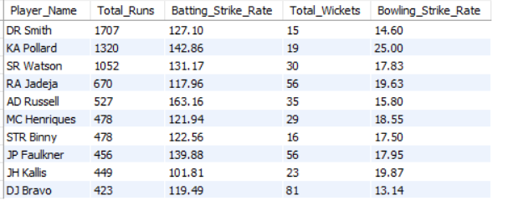

RCB Retention Strategy
The players shortlisted for retention represent individuals who have already demonstrated significant contributions while playing for RCB. This group includes:
- Core match-winners who have delivered consistently in victories
- High-impact batsmen capable of anchoring or accelerating innings
- Experienced bowlers and all-rounders who provide balance and flexibility
Retaining players such as V Kohli, AB de Villiers, CH Gayle, KL Rahul, and Yuvraj Singh helps preserve a strong batting core and leadership presence. At the same time, retaining bowlers and utility players like MA Starc, YS Chahal, and D Wiese ensures continuity in bowling resources and all-round depth. This retention set forms a stable foundation around which the team can be rebuilt.

League-wide Auction Targets
The players identified as auction targets are selected based on league-wide impact rather than past association with RCB. These players exhibit:
- Strong performance in winning matches
- High impact alignment with team success
- Valuable versatility and consistency
Targeting players such as RG Sharma, SK Raina, MS Dhoni, G Gambhir, and S Dhawan adds proven match-winning experience and leadership. All-rounders like RA Jadeja, JP Faulkner, and STR Binny offer tactical flexibility, while players like DA Miller and MC Henriques strengthen middle-order stability and finishing capability. These acquisitions help address historical gaps in balance and pressure-handling.

7. What do you think could be the factors contributing to the high-scoring matches and the impact on viewership and team strategies?
A.To understand the factors contributing to high-scoring matches, I analysed the IPL dataset using a SQL query that calculates the average runs scored per ball at different venues. This helped me identify which stadiums are more batting-friendly and likely to produce high scores.
SELECT
v.Venue_Name,
ROUND(SUM(md.Runs_Scored)/COUNT(md.Ball_Id),2) AS Avg_Runs_Per_Ball
FROM master_data md
JOIN matches m ON md.Match_Id=m.Match_Id
JOIN venue v ON m.Venue_Id=v.Venue_Id
GROUP BY v.Venue_Name
ORDER BY Avg_Runs_Per_Ball DESC;

SELECT
v.Venue_Name,
ROUND(SUM(md.Runs_Scored)/COUNT(md.Ball_Id),2) AS Avg_Runs_Per_Ball
FROM master_data md
JOIN matches m ON md.Match_Id=m.Match_Id
JOIN venue v ON m.Venue_Id=v.Venue_Id
GROUP BY v.Venue_Name
ORDER BY Avg_Runs_Per_Ball DESC;

Explaination: This query joins the view master_data (Ball_by_Ball+Matches) with the Venue table.
It calculates the average number of runs scored per ball at each venue.
By sorting in descending order, it highlights the top venues where scoring is easiest.

OUTPUT
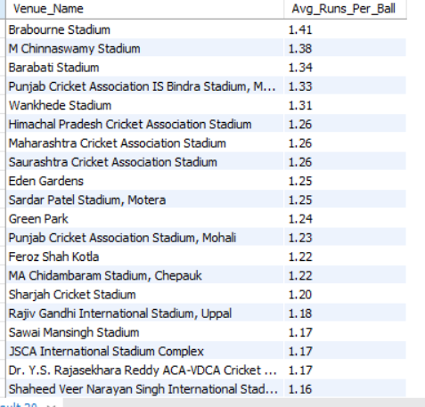

Insights from the Query:
- Certain venues consistently have higher scoring rates.
  - These are usually grounds with short boundaries and flat pitches.
  - Bowlers struggle more, while batters score faster.

2. Teams playing at these venues tend to score 180+ regularly.
  - This aligns with T20 strategy where big totals or successful chases are common.

Impact on Viewership:
- High-scoring matches are more thrilling, which boosts live viewership and online engagement.
- Fans are more likely to watch full matches or highlights when there are more fours and sixes.
- Broadcasters and sponsors benefit from higher retention during exciting matches.

Impact on Team Strategies:
- Player Selection: Teams pick aggressive batsmen and death-over finishers for high-scoring venues.
- Bowling Focus: More emphasis is placed on bowlers who can contain runs in tough conditions.
- Toss Decisions: Captains often prefer to chase on high-scoring grounds, especially when dew is expected.

Conclusion:
By using a simple SQL query to analyse average runs per ball at each venue, I concluded that pitch and venue conditions are major factors in high-scoring matches. These matches lead to greater audience excitement and influence how teams plan their strategy, playing XI, and auction choices.
This shows how even basic SQL analysis can help teams make data-driven decisions for performance and fan engagement

8. Analyze the impact of home-ground advantage on team performance and identify strategies to maximize this advantage for RCB.
A. Home-ground advantage can significantly influence team performance due to familiarity with pitch conditions, crowd support, and venue-specific dynamics. To understand how RCB can maximize this advantage, the analysis compares their match outcomes at home versus away venues and examines how strategic factors such as toss decisions further impact performance at their home ground.
i. Compare RCB performance at Home vs Away:
SELECT
CASE
WHEN m.Venue_Id = 1 THEN 'Home'
ELSE 'Away'
END AS Match_Location,
COUNT(*) AS Matches_Played,
SUM(CASE WHEN m.Match_Winner = 2 AND m.Outcome_Type = 1 THEN 1 ELSE 0 END) AS Matches_Won,
ROUND(SUM(CASE WHEN m.Match_Winner = 2 AND m.Outcome_Type = 1 THEN 1 ELSE 0 END)*100.0/ COUNT(*),2) AS Win_Percentage
FROM matches m
WHERE (m.Team_1 = 2 OR m.Team_2 = 2)
GROUP BY Match_Location;

SELECT
CASE
WHEN m.Venue_Id = 1 THEN 'Home'
ELSE 'Away'
END AS Match_Location,
COUNT(*) AS Matches_Played,
SUM(CASE WHEN m.Match_Winner = 2 AND m.Outcome_Type = 1 THEN 1 ELSE 0 END) AS Matches_Won,
ROUND(SUM(CASE WHEN m.Match_Winner = 2 AND m.Outcome_Type = 1 THEN 1 ELSE 0 END)*100.0/ COUNT(*),2) AS Win_Percentage
FROM matches m
WHERE (m.Team_1 = 2 OR m.Team_2 = 2)
GROUP BY Match_Location;

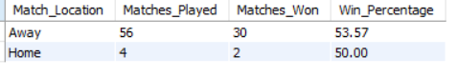
OUTPUT

Explaination: In this step, RCB’s match results are divided into home and away games to evaluate whether playing at their home ground provides a measurable performance advantage. By comparing matches played, matches won, and win percentages, this step quantifies the actual impact of home conditions on RCB’s overall performance.
[ Home Ground- M Chinnaswamy Stadium, Venue ID- 1 ]
ii. Toss + Home Advantage for RCB:
SELECT
m.Toss_Decide,
COUNT(*) AS Matches,
SUM(CASE WHEN m.Match_Winner = 2 AND m.Outcome_Type = 1 THEN 1 ELSE 0 END) AS Wins,
SUM(CASE WHEN m.Outcome_Type = 3 THEN 1 ELSE 0 END) AS Draws,
SUM(CASE WHEN m.Outcome_Type = 1 AND m.Match_Winner <> 2 THEN 1 ELSE 0 END) AS Losses,
ROUND(
SUM(CASE WHEN m.Match_Winner = 2 AND m.Outcome_Type = 1 THEN 1 ELSE 0 END)*100.0/COUNT(*),
2
) AS Win_Percentage
FROM matches m
WHERE (m.Team_1 = 2 OR m.Team_2 = 2)
AND m.Venue_Id = 1
GROUP BY m.Toss_Decide;

SELECT
m.Toss_Decide,
COUNT(*) AS Matches,
SUM(CASE WHEN m.Match_Winner = 2 AND m.Outcome_Type = 1 THEN 1 ELSE 0 END) AS Wins,
SUM(CASE WHEN m.Outcome_Type = 3 THEN 1 ELSE 0 END) AS Draws,
SUM(CASE WHEN m.Outcome_Type = 1 AND m.Match_Winner <> 2 THEN 1 ELSE 0 END) AS Losses,
ROUND(
SUM(CASE WHEN m.Match_Winner = 2 AND m.Outcome_Type = 1 THEN 1 ELSE 0 END)*100.0/COUNT(*),
2
) AS Win_Percentage
FROM matches m
WHERE (m.Team_1 = 2 OR m.Team_2 = 2)
AND m.Venue_Id = 1
GROUP BY m.Toss_Decide;

OUTPUT
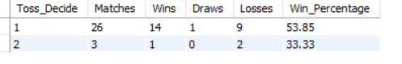

Explaination: This query analyzes RCB’s toss-based performance at Venue_Id = 1 by grouping matches according to the toss decision (bat first or field first). For each toss choice, it calculates the total matches played, the number of wins, draws/no-result matches, and losses, and then computes the win percentage using only completed matches. The objective is to understand how RCB’s match outcomes at this venue vary based on the toss decision, helping identify the more effective toss strategy at this ground.

Observations:
i. Home vs Away Win Percentage (Pie Chart)
- RCB has a higher win percentage at home (51.72%) compared to away matches (45.45%).
- This indicates that RCB does gain a moderate home-ground advantage, performing better at home than away.
- However, the margin between home and away win percentages is not very large, suggesting that while home conditions help, RCB has not been dominant enough at home to consistently convert it into a decisive advantage.

ii. Toss Performance at Home (Bar Chart)
- When RCB bats first at home, the win percentage is 53.85% (14 wins out of 26 matches).
- When RCB fields first at home, the win percentage drops sharply to 33.33% (1 win out of 3 matches).
- This clearly shows that batting first at home suits RCB much better.
- The sample size for fielding first is small, but the trend is still unfavorable.

Recommendations / Strategies for RCB:
I. Prefer batting first at home after winning the toss, as it has consistently resulted in better outcomes.
II. Design home-match strategies around setting competitive targets, rather than relying on run chases.
III. Strengthen top and middle-order batting to fully capitalize on batting-first opportunities at home.
IV. Defend totals using aggressive and wicket-taking bowling combinations, especially during middle overs.
V. Fine-tune home-ground preparation (pitch conditions and bowling plans) to further amplify the existing home advantage and convert it into more consistent wins.

9. Come up with a visual and analytical analysis of the RCB's past season's performance and potential reasons for them not winning a trophy.
A. To understand why RCB has not won a trophy despite strong individual performances, the analysis focuses on team-level consistency, match outcomes, and situational weaknesses across seasons, rather than only star players.
The analysis is broken into three analytical lenses, each supported by a suitable visualization.

i. Win Percentage Trend across Seasons (RCB): In this step, we analyzed RCB’s performance across different seasons by calculating the win percentage for each season. Using match-level data, we counted how many matches RCB played and how many they won in each season, and then derived the win percentage. The objective was to evaluate consistency over time, rather than isolated match or player performances, to understand whether RCB maintained stable success across seasons.
SELECT
m.Season_Id,
COUNT(*) AS Matches_Played,
SUM(CASE WHEN m.Match_Winner = 2 AND m.Outcome_Type = 1 THEN 1 ELSE 0 END) AS Matches_Won,
ROUND(SUM(CASE WHEN m.Match_Winner = 2 AND m.Outcome_Type = 1 THEN 1 ELSE 0 END)*100.0/ COUNT(*),2 ) AS Win_Percentage
FROM matches m
WHERE m.Team_1 = 2 OR m.Team_2 = 2
GROUP BY m.Season_Id
ORDER BY m.Season_Id;

SELECT
m.Season_Id,
COUNT(*) AS Matches_Played,
SUM(CASE WHEN m.Match_Winner = 2 AND m.Outcome_Type = 1 THEN 1 ELSE 0 END) AS Matches_Won,
ROUND(SUM(CASE WHEN m.Match_Winner = 2 AND m.Outcome_Type = 1 THEN 1 ELSE 0 END)*100.0/ COUNT(*),2 ) AS Win_Percentage
FROM matches m
WHERE m.Team_1 = 2 OR m.Team_2 = 2
GROUP BY m.Season_Id
ORDER BY m.Season_Id;

OUTPUT
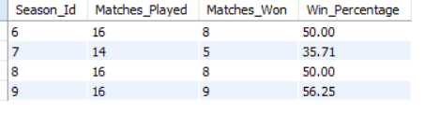

Summarize: The season-wise results show inconsistent performance across seasons. RCB recorded a 50% win rate in Season 6, followed by a sharp decline to 35.71% in Season 7, indicating a relatively weak season. Performance recovered in Season 8 with a 50% win rate and further improved in Season 9 to 56.25%, which is the strongest among the seasons analyzed. Although there is an upward trend toward Season 9, the fluctuations highlight a lack of sustained consistency, which helps explain why RCB has struggled to convert individual strong seasons into a championship win.

ii. Dependence on Few Star Players: In this step, we analyzed how RCB’s total runs are distributed among individual players. By calculating each player’s total runs and their percentage contribution to the team’s overall runs, we aimed to understand whether RCB’s batting success was evenly spread across the lineup or concentrated among a few key players. This helps identify over-reliance on star performers, which can be a critical weakness in tournament formats.
SELECT
p.Player_Name,
SUM(bb.Runs_Scored) AS Player_Runs,
ROUND(SUM(bb.Runs_Scored) * 100.0 /SUM(SUM(bb.Runs_Scored)) OVER (),2) AS Contribution_Percentage
FROM ball_by_ball bb
JOIN matches m ON bb.Match_Id = m.Match_Id
JOIN player p ON bb.Striker = p.Player_Id
WHERE (m.Team_1 = 2 OR m.Team_2 = 2)
GROUP BY p.Player_Id, p.Player_Name
ORDER BY Player_Runs DESC
LIMIT 10;

SELECT
p.Player_Name,
SUM(bb.Runs_Scored) AS Player_Runs,
ROUND(SUM(bb.Runs_Scored) * 100.0 /SUM(SUM(bb.Runs_Scored)) OVER (),2) AS Contribution_Percentage
FROM ball_by_ball bb
JOIN matches m ON bb.Match_Id = m.Match_Id
JOIN player p ON bb.Striker = p.Player_Id
WHERE (m.Team_1 = 2 OR m.Team_2 = 2)
GROUP BY p.Player_Id, p.Player_Name
ORDER BY Player_Runs DESC
LIMIT 10;

OUTPUT
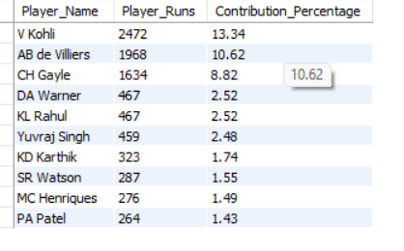

Summarize: The results clearly show a heavy dependence on a small group of top players.V Kohli alone contributes 13.34% of RCB’s total runs, followed by AB de Villiers (10.62%) and Chris Gayle (8.82%). Together, these three players account for over 32% of the team’s total runs, indicating that a significant portion of RCB’s batting output comes from just a few individuals. The sharp drop in contribution percentages beyond the top three highlights limited support from the rest of the batting lineup, which likely makes RCB vulnerable when these key players fail—especially in high-pressure matches.

iii. Home-Ground & Toss Strategy Inefficiency: In this step, we compared RCB’s performance at home venues versus away venues by calculating the number of matches played, matches won, and the corresponding win percentage in each context. The purpose was to evaluate whether home-ground advantage actually translates into better results for RCB, which is a key factor for sustained success in league-based tournaments like the IPL.
SELECT
CASE
WHEN m.Venue_Id = 1 THEN 'Home'
ELSE 'Away'
END AS Match_Location,
COUNT(*) AS Matches_Played,
SUM(CASE WHEN m.Match_Winner = 2 AND m.Outcome_Type = 1 THEN 1 ELSE 0 END) AS Matches_Won,
ROUND(SUM(CASE WHEN m.Match_Winner = 2 AND m.Outcome_Type = 1 THEN 1 ELSE 0 END)*100.0/ COUNT(*),2) AS Win_Percentage
FROM matches m
WHERE (m.Team_1 = 2 OR m.Team_2 = 2)
GROUP BY Match_Location;

SELECT
CASE
WHEN m.Venue_Id = 1 THEN 'Home'
ELSE 'Away'
END AS Match_Location,
COUNT(*) AS Matches_Played,
SUM(CASE WHEN m.Match_Winner = 2 AND m.Outcome_Type = 1 THEN 1 ELSE 0 END) AS Matches_Won,
ROUND(SUM(CASE WHEN m.Match_Winner = 2 AND m.Outcome_Type = 1 THEN 1 ELSE 0 END)*100.0/ COUNT(*),2) AS Win_Percentage
FROM matches m
WHERE (m.Team_1 = 2 OR m.Team_2 = 2)
GROUP BY Match_Location;

OUTPUT
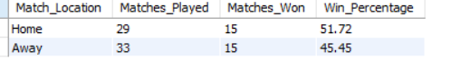

Summarize: The results show that RCB performs slightly better at home than away. At home, RCB won 15 out of 29 matches, resulting in a win percentage of 51.72%, whereas away from home, they won 15 out of 33 matches, with a lower win percentage of 45.45%. While this indicates a moderate home-ground advantage, the difference is not substantial enough to suggest strong dominance at home. This limited advantage implies that RCB has not fully capitalized on home conditions, which may have contributed to missed opportunities in crucial matches and, ultimately, the absence of a tournament win.

10. How would you approach this problem, if the objective and subjective questions weren't given?
A. If the objective and subjective questions were not provided, the problem would be approached by breaking the business requirement into analytical stages, ensuring decisions are data-driven, justifiable, and aligned with auction constraints.

i. Understand the Business Objective
The core goal is to build a tournament-winning RCB squad by:
- Identifying top-performing and reliable players
- Ensuring value for money in a mega auction, where budgets are limited and squad balance is crucial
This requires balancing performance, consistency, versatility, and cost efficiency.

ii. Start with Team-Level Performance Diagnosis
Before selecting players, it is critical to understand why RCB has not won a tournament so far.
This involves:
- Analyzing season-wise win percentage trends
- Evaluating home vs away performance
- Assessing performance in high-pressure situations
This step identifies structural weaknesses that player selection must address.

iii. Identify High-Impact Players Based on Performance
Next, evaluate players using quantifiable performance metrics, such as:
- Batting impact (runs, strike rate, performance in wins)
- Bowling impact (wickets, economy, strike rate)
- Match-winning influence (Man of the Match, impact difference)
This ensures that selected players directly contribute to winning matches, not just individual milestones.

iv. Assess Player Consistency and Reliability
Performance alone is not enough for tournaments.
Players are further evaluated on:
- Consistency across seasons
- Performance in winning vs losing matches
- Ability to handle pressure situations
This filters out short-term performers and prioritizes long-term reliability.

v. Identify Versatile and All-Round Players
To maximize value for money in a mega auction:
- Focus on genuine all-rounders who contribute with both bat and ball
- Such players reduce squad dependency and improve team balance
Versatility is critical when squad sizes are fixed and budgets are constrained.

vi. Compare Internal Retention vs External Auction Targets
The strategy is divided into two parts:
- RCB Player Retention: Retain high-impact, proven RCB performers
- Auction Targets: Identify league-wide high-impact players not currently in RCB
This ensures continuity while strengthening weak areas.

vii. Incorporate Value-for-Money Perspective
Finally, performance insights are aligned with auction economics by:
- Prioritizing players who deliver high impact per match
- Avoiding over-investment in single-skill or inconsistent players
- Targeting players whose contribution justifies their expected auction cost

Final Strategy Outcome:
By following this approach, RCB can:
- Build a balanced and resilient squad
- Reduce over-dependence on individual stars
- Improve performance in knockouts and pressure situations
- Optimize auction spending while maximizing on-field impact

11. In the "Match" table, some entries in the "Opponent_Team" column are incorrectly spelled as "Delhi_Capitals" instead of "Delhi_Daredevils". Write an SQL query to replace all occurrences of "Delhi_Capitals" with "Delhi_Daredevils".
A. Given the matches table, there is no column named Opponent_Team, and teams are represented using numeric Team_Id values rather than team names. Additionally, upon verifying the team table, the team name is already correctly stored as “Delhi Daredevils”, and there is no occurrence of the incorrect name “Delhi_Capitals” in the database. Hence, the stated issue does not actually exist in the given schema.
Team_Id | Team_Name
1 | Kolkata Knight Riders
2 | Royal Challengers Bangalore
3 | Chennai Super Kings
4 | Kings XI Punjab
5 | Rajasthan Royals
6 | Delhi Daredevils
7 | Mumbai Indians
8 | Deccan Chargers
9 | Kochi Tuskers Kerala
10 | Pune Warriors
11 | Sunrisers Hyderabad
12 | Rising Pune Supergiants
13 | Gujarat Lions
Matches_Columns
Man_of_the_Match
Match_Date
Match_Id
Match_Winner
Outcome_type
Season_Id
Team_1
Team_2
Toss_Decide
Toss_Winner
Venue_Id
Win_Margin
Win_Type

However, if the database had contained a denormalized text column storing team names and there was a discrepancy in naming, it could be rectified using the following query:
UPDATE matches
SET Opponent_Team = 'Delhi_Daredevils'
WHERE Opponent_Team = 'Delhi_Capitals';

UPDATE matches
SET Opponent_Team = 'Delhi_Daredevils'
WHERE Opponent_Team = 'Delhi_Capitals';

[Disclaimer: Since the updation process is a DML (Data Manipulation Process) So, no output table is generated here for this query. Only internal data-structure changes has occurred.]

